-
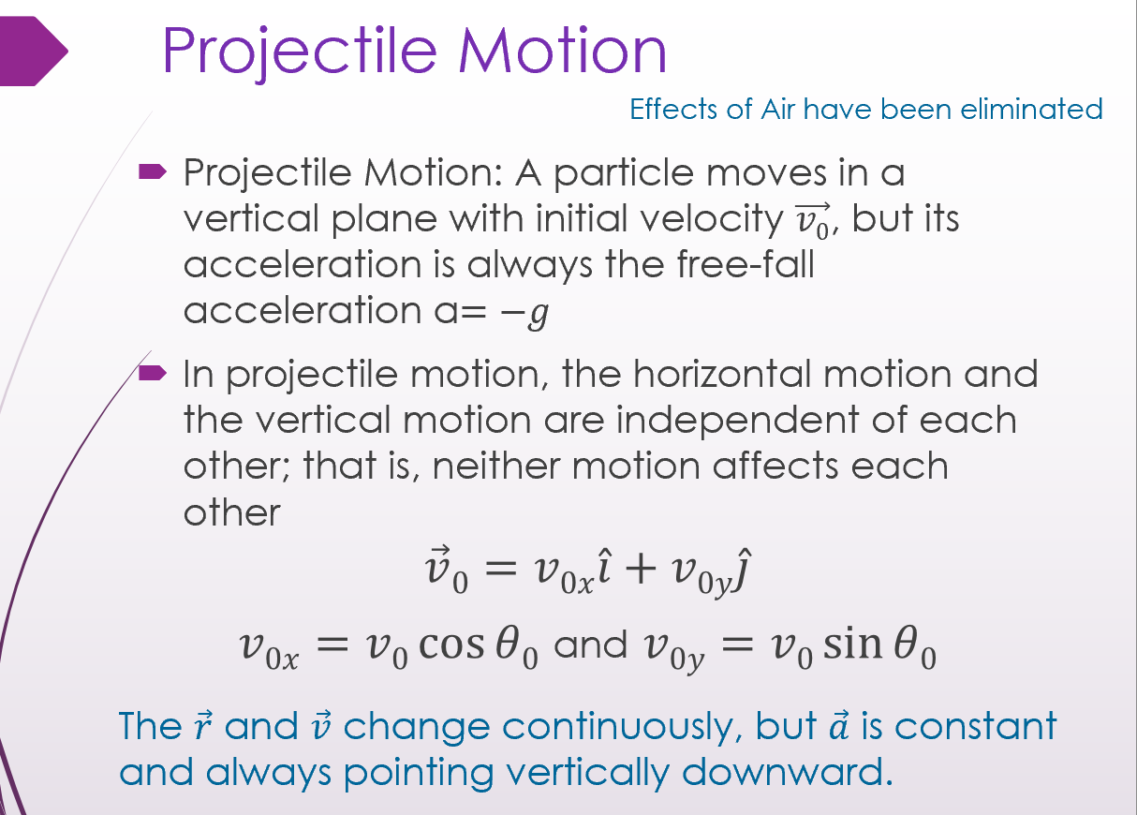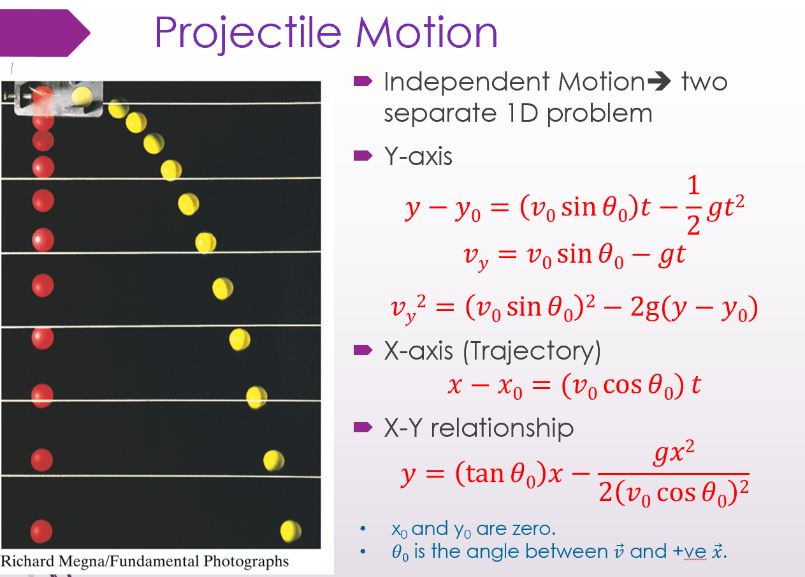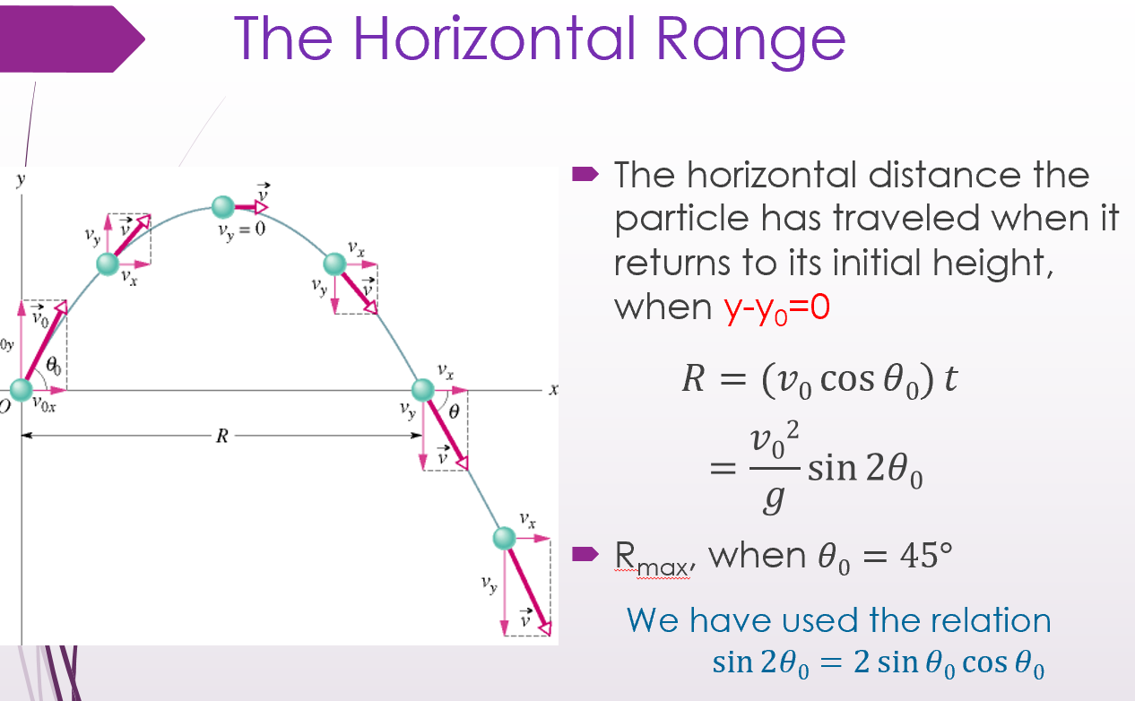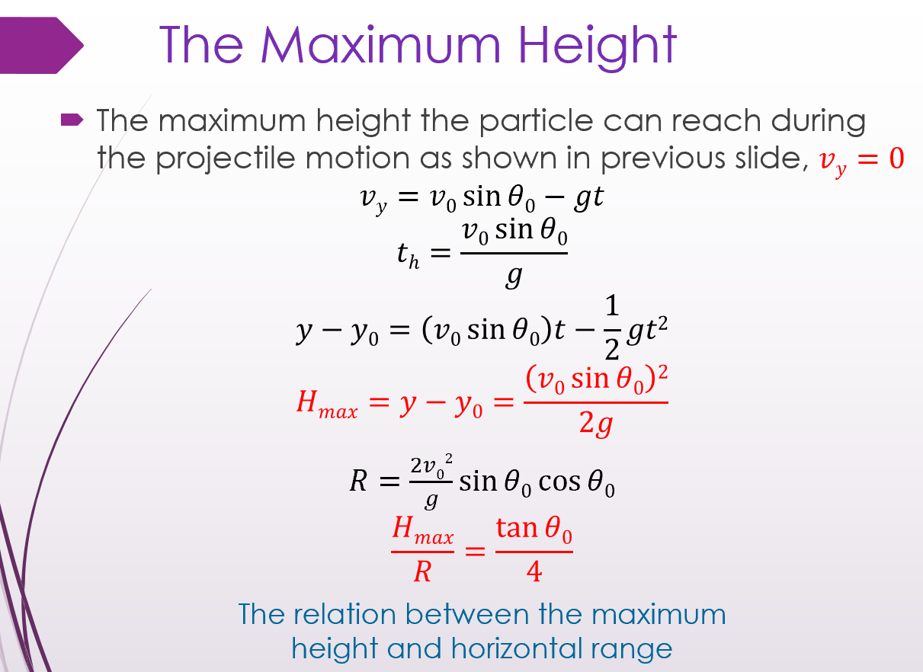
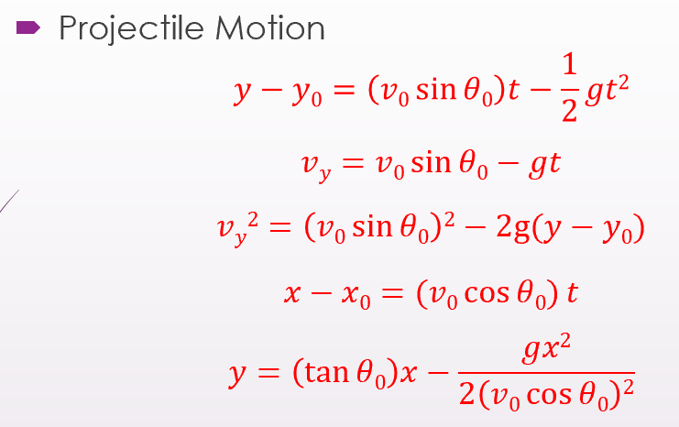
周期 T: The period of revolution or simply period
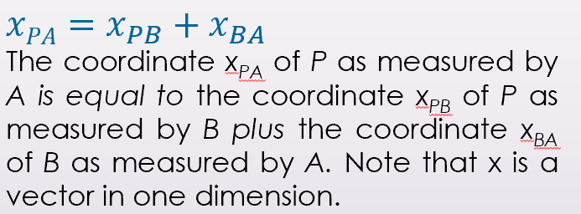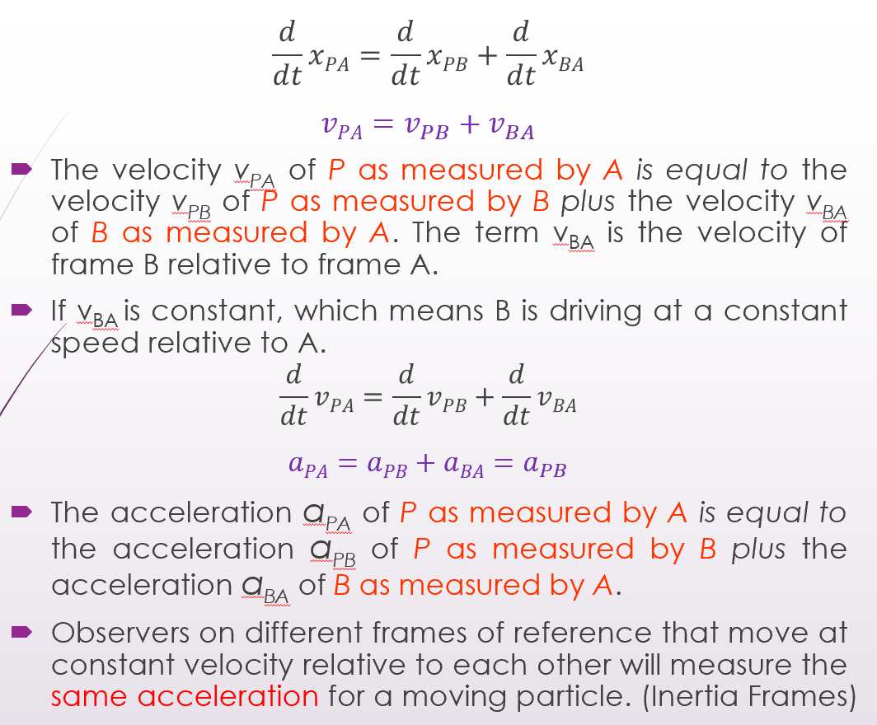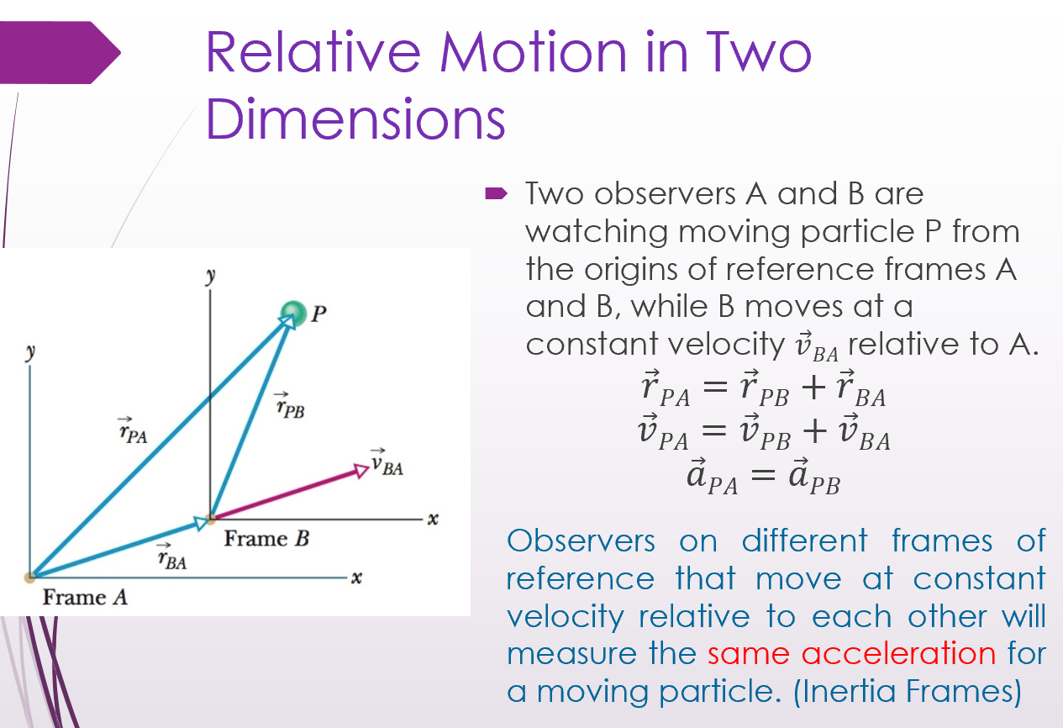
-
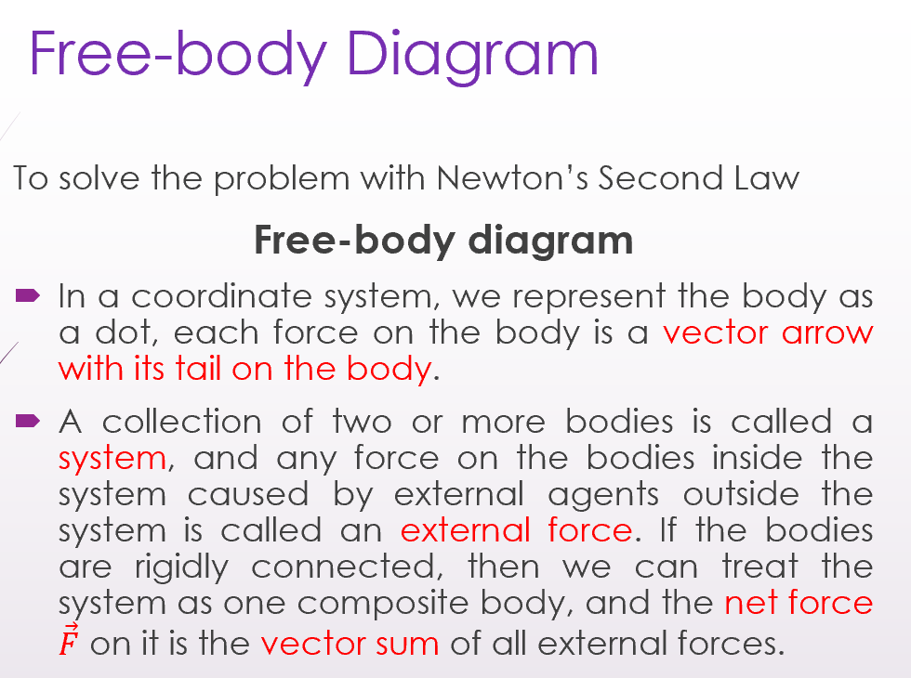
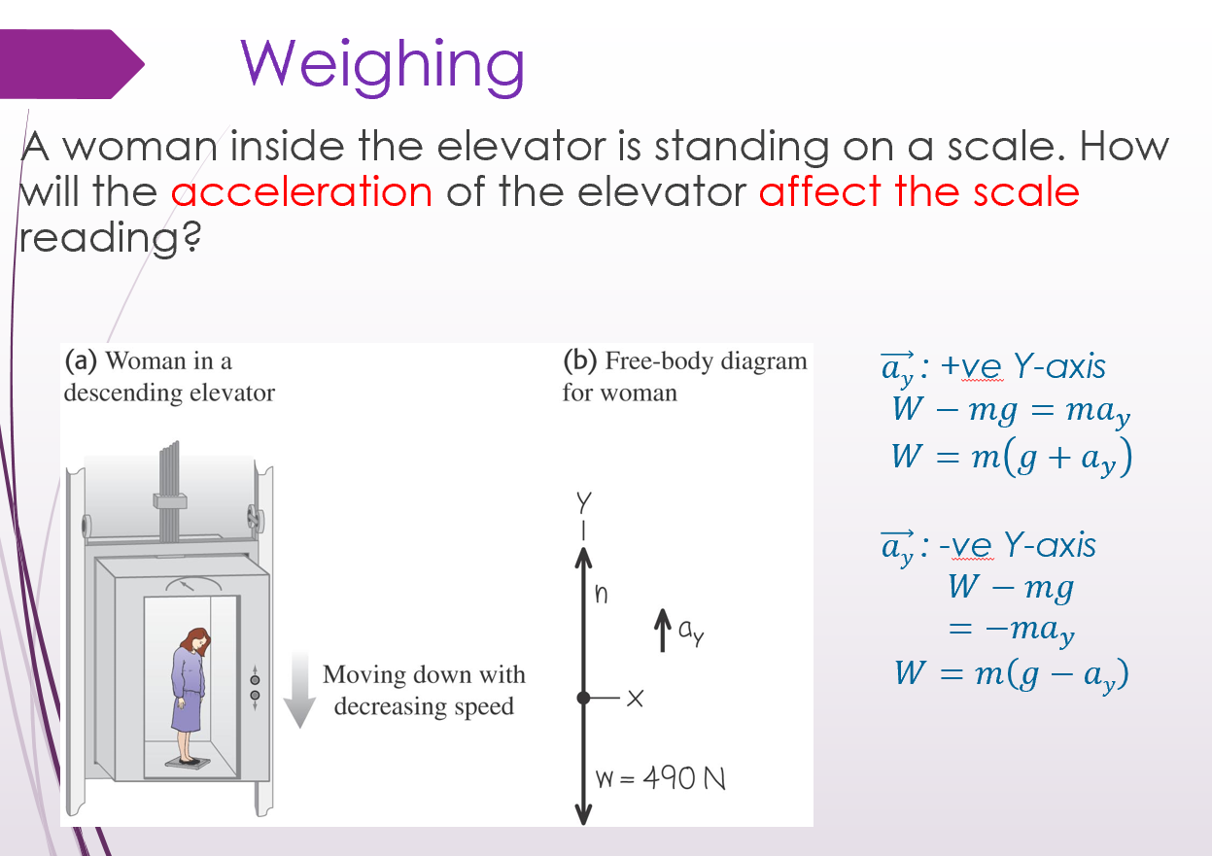

Ch6 Force and Motion-II
——Friction, The Drag Force, Terminal Speed, Uniform Circular Motions
-Friction 摩擦
When a force $\vec{F}$ tends to slide a body along a surface, a frictional force $\vec{f}$ from the surface acts on the body. The frictional force is parallel to the surface and directed so as to oppose the sliding. It is due to the bonding between the body and the surface
-Static Frictional Force $\vec{f_{s}}$ 静摩擦力
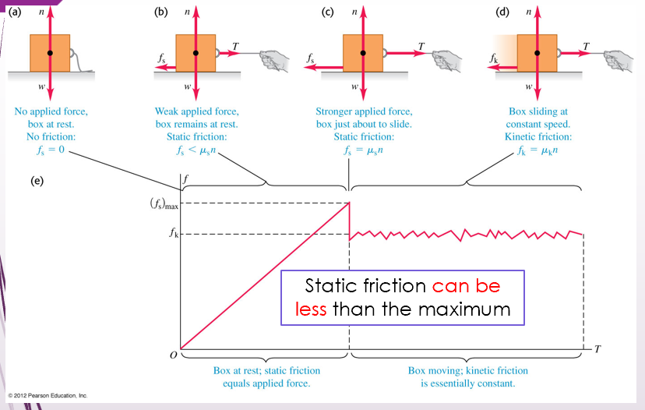
-Kinetic Frictional Force $\vec{f_{k}}$ 动摩擦力

-Microscopic View of Friction

-Cold-Weld
3D Surface profile of a-well polished metal by AFM
Far from being flat in atomic scale
Covered with metal oxide layer
-...
-Properties of Friction
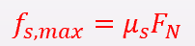 μ_s: Coefficient of static friction; F_N: Normal Force
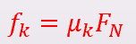 μ_k: Coefficient of kinetic friction; F_N: Normal Force
F_N: How firmly the body presses against the surface.
F_CB=-F_BC
•The harder you press, the larger the Normal Force
•(F_N ) ⃗ ⊥ (f_s ) ⃗/(f_k ) ⃗

μ_s/μ_k: Dimensionless, must be determined experimentally
•Depends on the body and surface
•μ_k: Assume the value doesn‘t depends on the speed at which the body slides along the surface
-Friction in Horizontal Motion
-The Drag Force 拖拽力
Fluid 流体
Def.: Anything that can flow, either gas or liquid.
e.g. Air / Water
Drag Force ($\vec{D}$) 拖拽力
Def.: When there is a relative velocity between a fluid and a body, the body experiences a drag force.
e.g. Blunt body and fast relative motion in air
Direction: Opposes the relative motion and points in the direction in which the fluid flows relative to the body.
·$D=\frac{1}{2} C ρ A v^{2}$
C: drag coefficient
(C: Typical values range from 0.4 to 1.0; and we use it as constant here. )
ρ: air density
A: effective cross-sectional area (perpendicular to the velocity)
v: relative speed
( Drag force是指当一个物体相对于周围流体运动时，与其相反的作用力。这种力可以存在于两个流体层（或表面）之间，也可以存在于流体和固体表面之间。当物体在流体中移动时，流体会产生阻力，称为拖曳力或拖曳。它与物体的运动方向相反，并由固体物体和流体之间的相对速度产生。 )
-Terminal Speed (v_{t}) 终端速度
Def.: When a blunt body falls from rest through air,
If |D| = |mg|,
then the body’s speed is constant (the acceleration a=0),
which is called terminal speed v_{t}
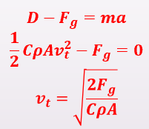
( Terminal Speed是指物体在流体（最常见的例子是空气）中下落时能达到的最大速度。当拖曳力（D）和浮力之和等于物体上的重力（F_{g}）向下的力时，就会发生这种情况。由于物体上的净力为零，所以物体的加速度为零 )
-Uniform Circular Motions
centripetal (adj.) 向心的
Centripetal force 向心力
A centripetal force accelerates a body by changing the direction of the body’s velocity without changing the body’s speed.
The centripetal force
Magnitude: 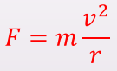 (F=ma, Magnitude of the acceleration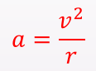)
The direction: Pointing to the center of the circle all the time
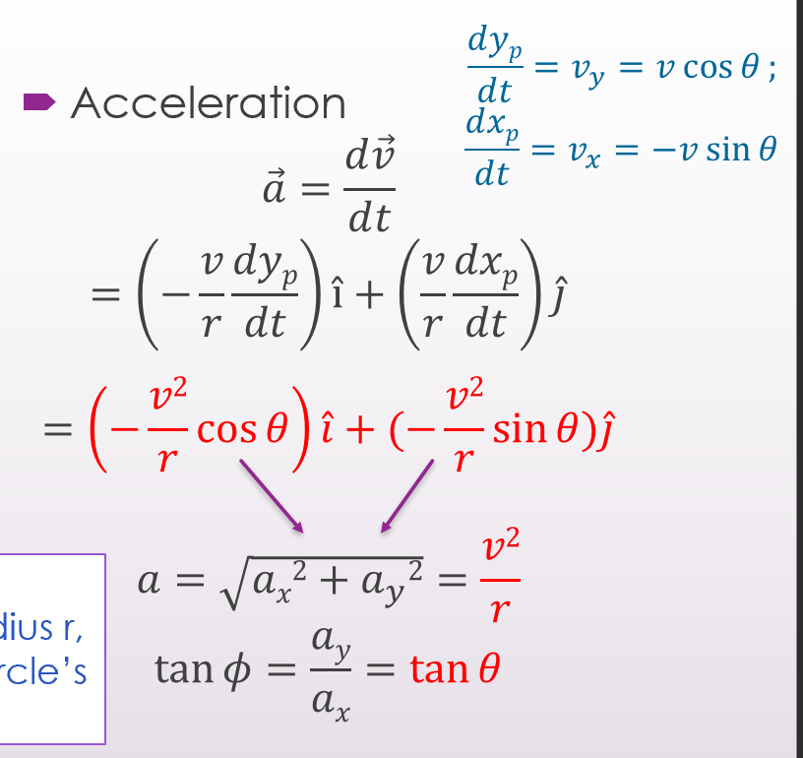

Ch8
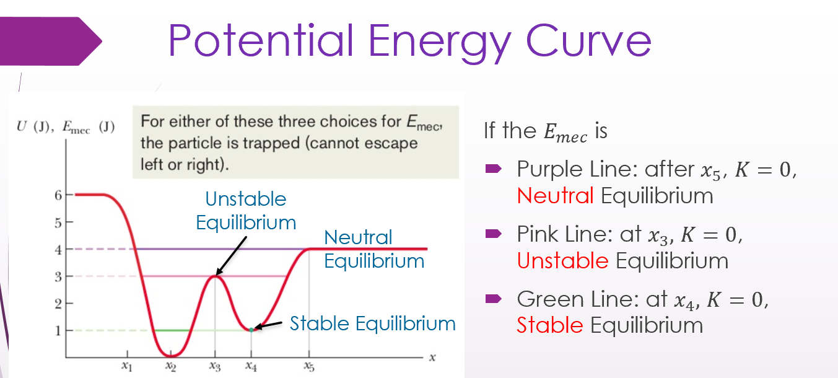
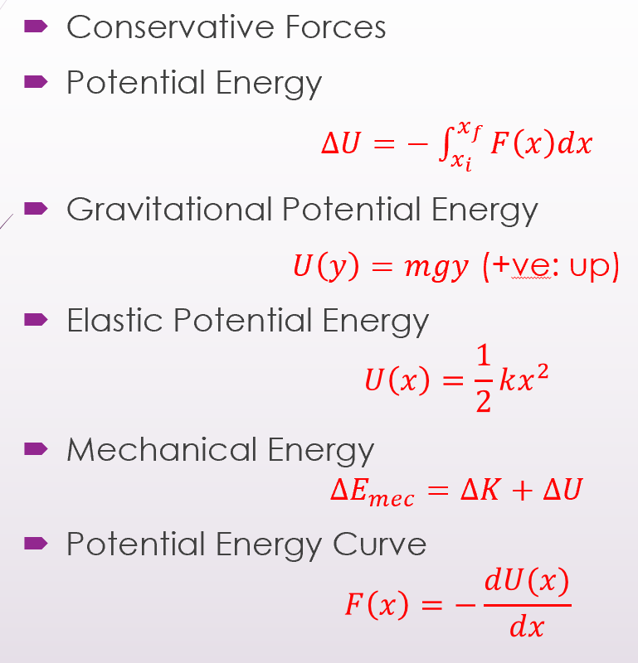
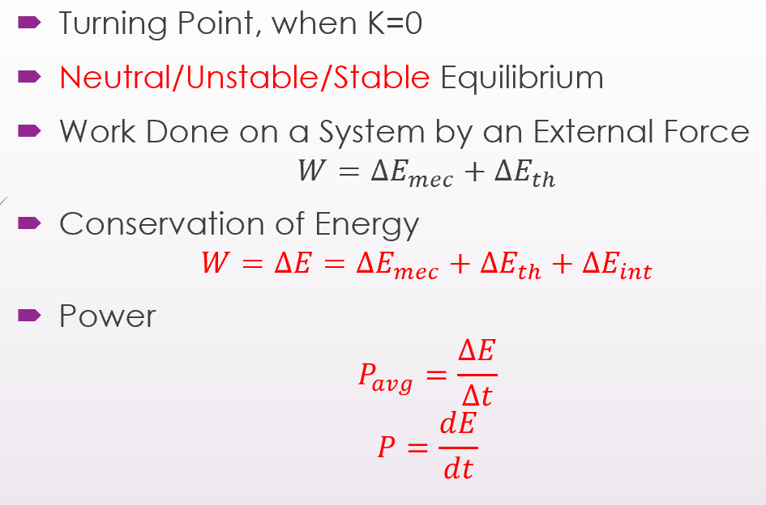
∆E_mec机械能变化量、∆E_th热能变化量、∆E_int内能变化量

Ch9
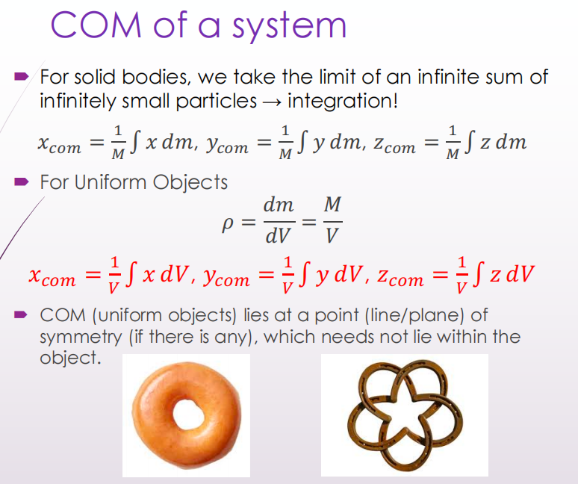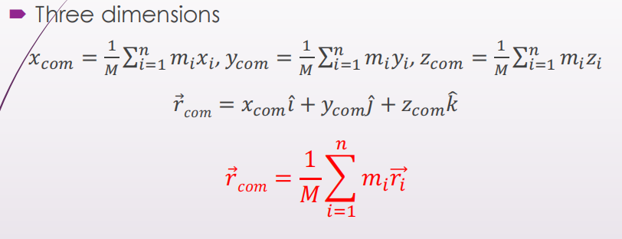
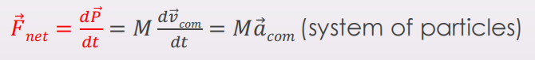
Elastic (adj.)弹性的
Elastic Collisions 弹性碰撞
Inelastic (adj.)非弹性的
Inelastic Collisions非弹性碰撞
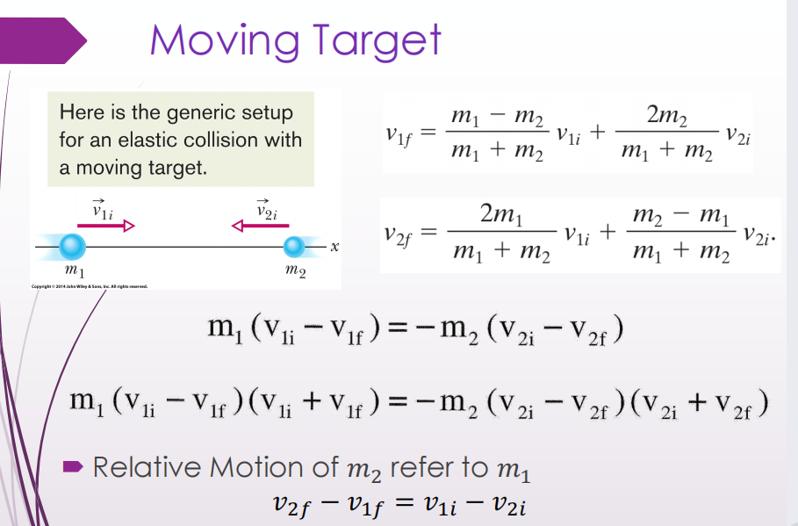
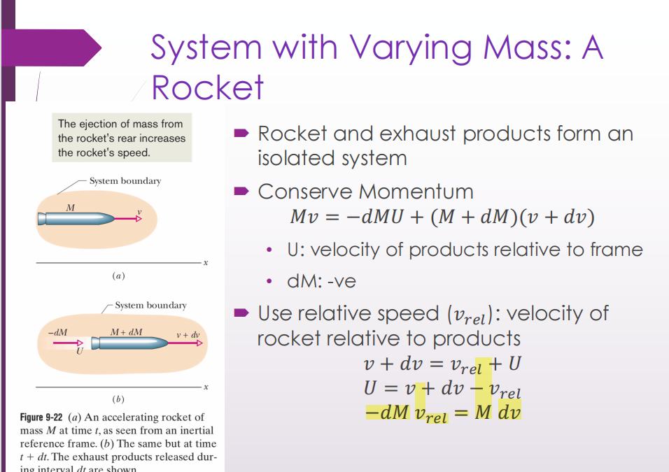
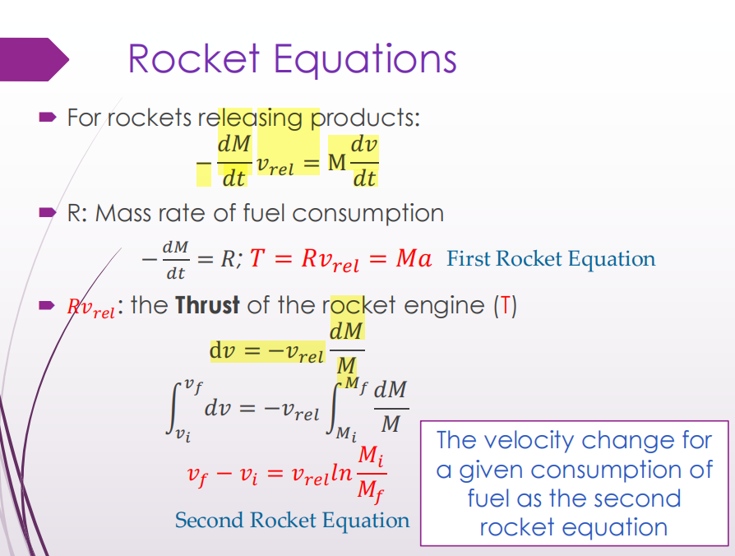 R=-dM/dt (!!!)
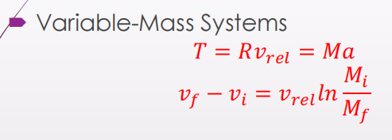
-System with Varying Mass: A Rocket
The ejection of mass from the rocket's rear increases the rocket's speed.
$(a)$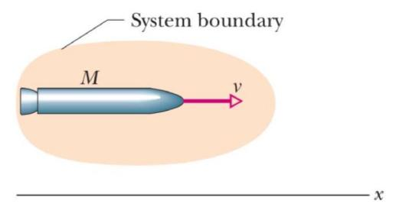 $(b)$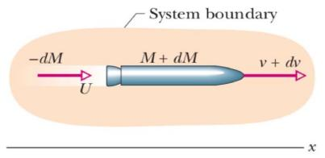
Figure 9-22
- An accelerating rocket of mass $M$ at time $t$, as seen from an inertial reference frame.
- The same but at time $t+dt$. The exhaust products released during interval $dt$ are shown. - Rocket and exhaust products form an isolated system
-Conserve Momentum
· $Mv=-dMU+(M+dM)(v+dv)$
U: velocity of products relative to frame
dM:-ve
Use relative speed $\left(v_{rel}\right)$ : velocity of rocket relative to products
· $\begin{matrix} & v+dv=v_{rel}+U \\ & U=v+dv -v_{rel} \\ & -dMv_{rel}=Mdv\end{matrix}$
-Rocket Equations
For rockets releasing products:
· $-\frac{dM}{dt}v_{rel}=M\frac{dv}{dt}$
R: Mass rate of fuel consumption $-\frac{dM}{dt}=R;$
$T=Rv_{rel}=Ma$
First Rocket Equation
R $v_{\text{rel }}$ : the Thrust of the rocket engine (T)
· $\begin{matrix}dv=-v_{rel}\frac{dM}{M} \\ \int_{v_{i}}^{v_{f}}{ } dv=-v_{rel}\int_{M_{i}}^{M_{f}}{ } \frac{dM}{M} \\ v_{f}-v_{i}=v_{rel}ln⁡\frac{M_{i}}{M_{f}}\end{matrix}$
The velocity change for a given consumption of fuel as the second rocket equation

Chapter10 Rotation
-Rotational Motion 旋转运动
Motion of Translation 平移运动
·move without spinning
·move along a straight or curved line
(Pure Translation 纯平移)
Motion of Rotation 旋转运动
·spin about an axis (rolling wheels)
-Rotational Variables 旋转变量
Rigid Body 刚体
Def.: A body can rotate with all its parts locked together and without any change in its shape
A Fixed Axis 固定轴
Def.: The rotation occurs about an axis that does not move, which is the axis of rotation (or rotation axis)
Pure Rotational 纯旋转
Def.: Every point moves in a circle whose center lies on the axis of rotation, and every point moves through the same angle during a particular time interval.
(Reference line参考线: 垂直于rotational axis旋转轴)
-Angular Position (θ) 角坐标
Angular Position of the reference line 参考线的角坐标
The angle θ of this line
relative to a fixed direction, which we take as the zero angular position零角位置.
· $θ=\frac{s}{r}$
θ: the angle of this line
s: the circular arc / The length of the point moves along an arc
r: the radius of the circle / Perpendicular distance from the rotational axis
* θ必须使用弧度制
For a circle:
· $1rev=360°=\frac{2πr}{r}=2π rad$
· $1rad=57.3°=0.159rev$
-Angular Displacement (Δθ)角位移
Def.: if the object rotates about the axis, changing the angular position of the reference line from θ1 to θ2
For rigid body: $Δθ=θ_{2}-θ_{1}$ 仅对刚体成立
Δθ is positive为正 ( Δθ > 0 ) - Counterclockwise逆时针
Δθ is negative为负 ( Δθ < 0 ) - Clockwise顺时针
-Angular Velocity (ω) 角速度
Def.: Angular Displacement during a time interval
Average Angular Velocity (ω_{avg}) 平均角速度:
· $ω_{avg}=\frac{θ_{2}-θ_{1}}{t_{2}-t_{1}}=\frac{Δθ}{Δt}$ ($Δθ=θ_{2}-θ_{1}$ 仅对刚体成立)
(Instantaneous) Angular Velocity (ω) 瞬时角速度:
· $ω=\lim_{Δt→0}{\frac{Δθ}{Δt}}=\frac{dθ}{dt}$
SI-unit 单位: rad/s
Angular Speed角速率(?)
Magnitude 指角速度ω的大小
-Angular Acceleration (α) 角加速度
Def.: Angular Velocity change during a time interval
Average Angular Acceleration
· $α_{avg}=\frac{ω_{2}-ω_{1}}{t_{2}-t_{1}}=\frac{Δω}{Δt}$
(Instantaneous) Angular Acceleration
· $α=\lim_{Δt→0}{\frac{Δω}{Δt}}=\frac{dω}{dt}$
Hold for every particle of the body 以上公式对任意物体都成立
SI-unit 单位: rad/s²
-Treat ω and α as vectors but not real vectors
Right-Hand Rule右手定则
ω and α: Rotate around the Vector, not move along the direction of the vector
(!!! Right-Hand Rule右手定则 用于判断 角速度ω和角加速度α 的方向)
For fixed rotational axis,
only two ways of rotation:
Counterclockwise - Positive(+)
Clockwise - Negative(-)
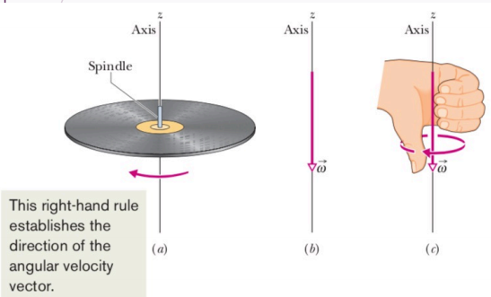
θ cannot be treated as vectors:
For vectors: $\vec{a}+\vec{b}=\vec{b}+\vec{a}$
For rotations about different axes: $\vec{θ_{1}}+\vec{θ_{2}}≠\vec{θ_{2}}+\vec{θ_{1}}$
For rotations about a fixed axis: $θ_{1}+θ_{2}=θ_{2}+θ_{1}$
-Comparison between Linear and Rotational Motion
One dimensional linear motion
VS. Rotation around a fixed axis
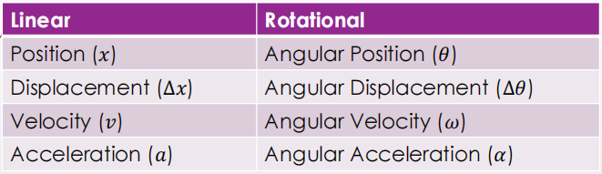
One dimensional linear motion with Constant Acceleration
VS. Rotation with Constant Acceleration
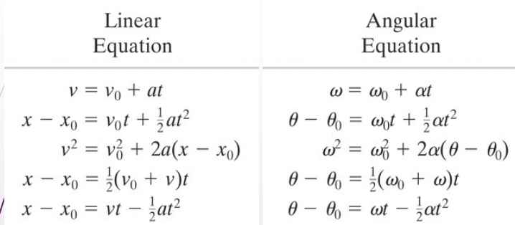
-Relating Linear and Angular Variables

· $s=θr (radian meaure)$
For all the linear-angular unit, must use the Radian relations弧度关系
无论是在何种情况下，如果要进行角度单位的转换或计算，都必须使用弧度制作为标准单位
(Radian relations弧度关系: 指在数学和物理学中，用弧度来表示角度的一组相关概念和公式)

· $v=ωr (radian measure)$
r: Constant (Radius); v: Speed; ω: Angular speed

a_{r}: Radial component of linear acceleration 线性加速度 的 径向分量
Pointed radially inward towards the center of the path
指向路径向心的方向
As long as the object is rotating, it is non-zero
even without any angular acceleration. (Uniform Circular Motion)
只要物体在旋转，即使没有任何角加速度(匀速圆周运动)，它也不为零.
Beacuse $T=\frac{2πr}{v}=\frac{2π}{ω} (radian measure)$
→ · $a_{r}=\frac{v^{2}}{r}=ω^{2}r (radian measure)$

a_{t}: Tangential component of linear acceleration 线性加速度 的 切向分量
Tangential direction to the rotational path
沿着旋转路径的切向方向
No angular acceleration ($ω$=0), a_{t} = 0 (Uniform Circular Motion)
没有角加速度(ω=0)时(匀速圆周运动)，a_{t} = 0
· $a_{t}=\frac{dv}{dt}=\frac{dω}{dt}r=αr (radian measure)$
-Kinetic Energy of Rotation (K) 旋转动能
Treat the rigid body as a collection of particles with different speeds
我们将刚体视为具有不同速度的粒子集合
· $K=\sum{\frac{1}{2}m_{i}}v_{i}^{2}=\frac{1}{2}(\sum{m_{i}r_{i}^{2}})ω^{2}=\frac{1}{2}Iω^{2}$
(K: 前-自然单位制 计算；后-弧度制 计算)
m_{i}: the mass of the i^{th} particle
v_{i}: the speed of the i^{th} particle
(· $v=ωr$ - The particle moves with same ω, but different v)
-Rotational Inertia (I) 转动惯量
(又名: Moment of inertia (也是)转动惯量)
Rotational Inertia of the body
with respect to the axis of rotation:
Involve both mass and its distribution
· $I=\sum{m_{i}r_{i}^{2}}$
Is a constant for a particular body and a particular rotational axis
· For (continuous(?)) rigid body: $I=\sum{m_{i}r_{i}^{2}}=\int{r^{2} dm}$xis
(?? 此处dm可写为 ? dr 的形式，然后在对于r的积分上，下边是相对于旋转轴的负坐标，上边是相对于旋转轴的正坐标 ?)
SI-unit 单位: kg·m²
对于特定物体和特定旋转轴而言，是一个恒量
(转动惯量 是指一个物体绕某个轴旋转时，由于该物体的形状、密度和质量分布等因素而产生的抵抗旋转运动的惯性。它衡量了物体在旋转时所表现出来的惯性大小。转动惯量越大，说明物体越难以旋转，需要更大的力矩才能使其旋转。
这就像线性运动中的质量(m)一样，质量越大，物体就越难以加速。)
(Moment of Inertia depends on the rotational axis
转动惯量 取决于旋转轴
这意味着对于同一个物体，当旋转轴改变时，它的转动惯量也会改变。这是因为转动惯量衡量了物体质量分布相对于旋转轴的情况。当旋转轴改变时，物体各部分与旋转轴的距离也会发生变化，从而影响到物体的转动惯量。
e.g., 考虑一个长方形薄片绕其一条边旋转和绕其对角线旋转。由于薄片各部分与两个旋转轴的距离不同，所以它们的转动惯量也不同。)
-The Parallel-Axis Theorem 平行轴定理
Have known the moment of inertia for the center of mass axis (I_{com})
→ Find the moment of inertia for a parallel axis (I)
· $I=I_{com}+Mh^{2}$
h: the perpendicular distance
between the axis that we need & the axis through the center of mass
(these two axes must be parallel; not valid for two arbitrary axes)
M: 物体的总质量
I: 物体绕 任意轴(所需求I的轴) 的转动惯量
I_{com}: 物体绕 过其重心的轴 旋转时的转动惯量
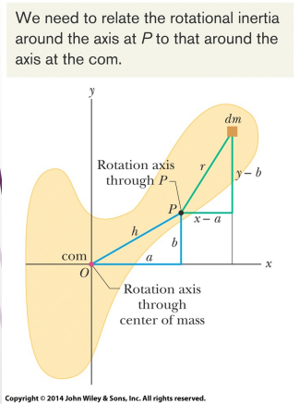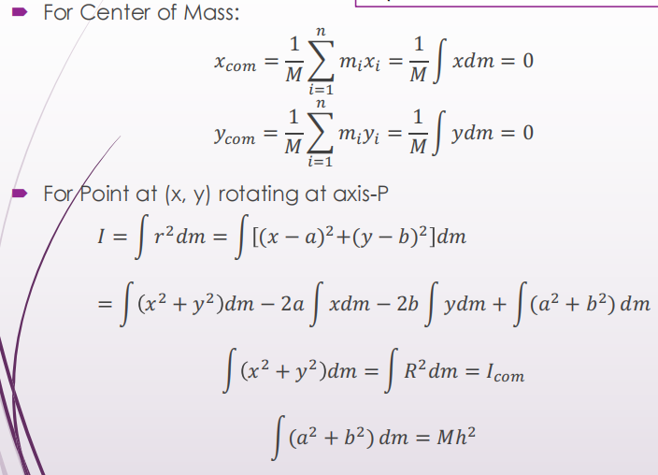
-Torque (τ) 扭矩/力矩/矩
The force necessary to rotate an object depends on
the angle of the force and where it is applied力的角度和被施加力的位置.
We can resolve the force into components to see how it affects rotation.
· $τ=(r)(F sinΦ)=r F_{⊥}=(r sinΦ)(F)=r_{⊥} F$
Torque can be treated as vectors:
· $\vec{τ}=\vec{r}×\vec{F}$
确定 $\vec{τ}$ 的方向：使用右手定则
Positive (+) direction - Counterclockwise 正方向 ( τ > 0 ) -逆时针
Negative (-) direction - Clockwise 负方向 ( τ < 0 ) -顺时针
( The line of action作用线 (also called line of application作用线) of a force (F)
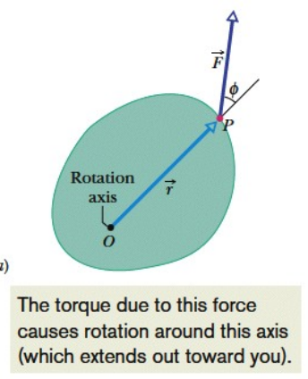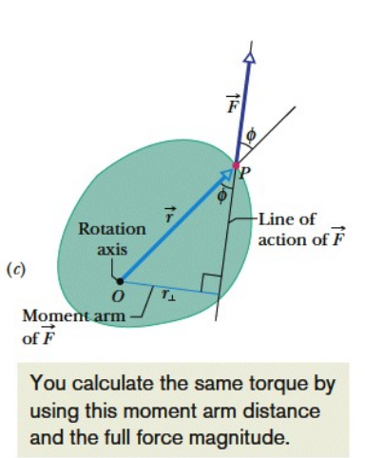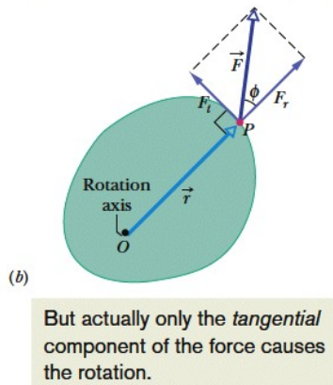
Def.: It is a geometric representation of how the force is applied. It is the line through the point at which the force is applied in the same direction as the vector $\vec{F}$.
力F的作用线 是力F的施加方式的几何表示；是通过力的作用点，并与向量$\vec{F}$方向相同的线。 )
Net torque (τ_{net}) 净力矩 (or resultant torque (τ_{net}) 合力矩)
Def.: is the sum of the individual torques
· $τ_{net}=\sum{τ_{i}}$
-Newton’s Second Law for Rotation 牛顿第二定律的旋转形式
Only the tangential component F_{t} of the applied force F can accelerate the particle along the path
只有作用力F的切向分量F_{t}才能沿着路径加速粒子
· $a_{t}=α r$
· $F_{t}=m a_{t}= m α r$
· $τ=F_{t} r=(m α r)×r=m α r^{2}=(m r^{2}) α=Iα$
For more than one force applied 对于一个以上的作用力:
· $τ_{net}=I α (radian measure)$
-Work and Rotational Kinetic Energy 功与旋转动能
Rotational Kinetic Energy旋转动能: $K=\frac{1}{2}Iω^{2}$
(· $ΔK=K_{f}-K_{i}=\frac{1}{2}mv_{f}^{2}-\frac{1}{2}mv_{i}^{2}=W$
· ↓ $v=ωr$
· $ΔK=\frac{1}{2}m{(ω_{f}r)}^{2}-\frac{1}{2}m{(ω_{i}r)}^{2}=W$
· ↓ $I=mr^{2}$
· $ΔK=\frac{1}{2}Iω_{f}^{2}-\frac{1}{2}Iω_{i}^{2}=W$
· → $K=\frac{1}{2}Iω^{2}$ )
( For translation motion: $W=\int_{x_{i}}^{x_{f}}{F dx}$ ;
Constant Force: $W=F(x_{f}-x_{i})$ ;
Power: $P=\frac{dW}{dt}=F v$ ;
For rotational motion about fixed Axis: $W=\int_{θ_{i}}^{θ_{f}}{τ dθ}$ ;
Constant Torque: $W=τ(θ_{f}-θ_{i}$) ;
Power: $P=\frac{dW}{dt}=τ \frac{dθ}{dt}=τ ω$
($ds=r dθ ; {dW=F}_{t} ds=F_{t}r dθ=τ dθ$)
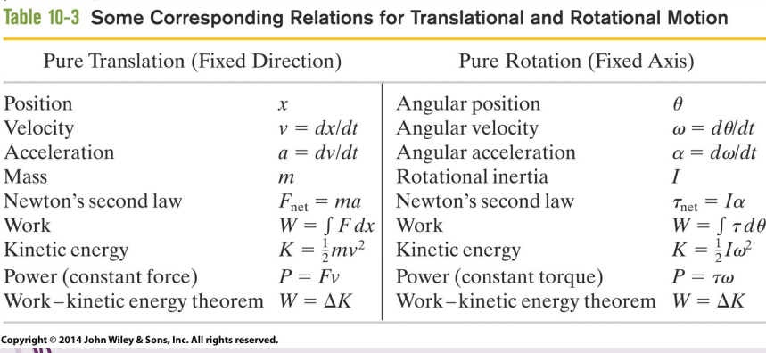
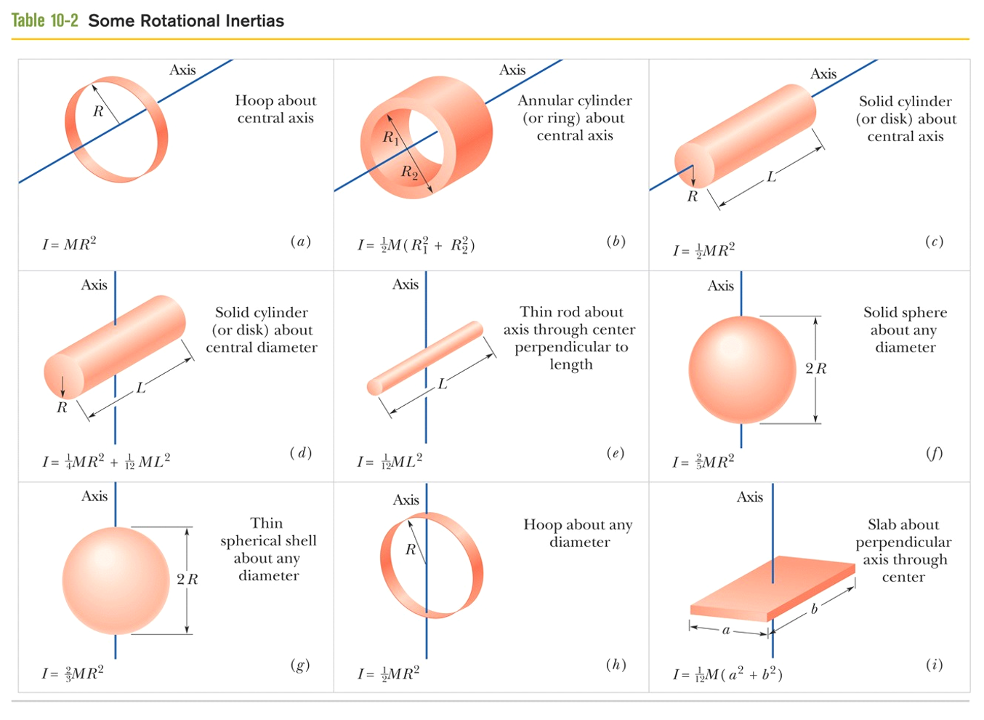

Ch11
-Rolling
-Translation in Rolling
-Rolling as Translation and Rotation Combined
-Rolling as Pure Rotation
-Same Angular Speed
-Direction of the Linear Velocity
-Newton’s 2nd Law for Smooth Rolling
-Torque Applied
-Force Applied
-Car: Connected wheels
-Rolling Down (Force Applied Case)
-Rolling Up (Force Applied Case)
-Kinetic Energy of Rolling
-Energy and Work done for Force Applied case
-Energy and Work done for Torque Applied Case
-Energy and Work done for Rolling along an incline
-The yo-yo
-The yo-yo with slipping
-Rolling and Slipping

-Angular momentum 角动量
· $\vec{l}=\vec{r}×\vec{p}=m (\vec{r}×\vec{v}) (Linear momentum \vec{p}=m \vec{v})$
-Newton’s Second Law in Angular Form
Translational Motion:
·$\vec{F_{net}}=\frac{d\vec{p}}{dt}$
Angular Form:
·$\vec{τ_{net}}=\frac{d\vec{l}}{dt}$ ($\vec{τ_{net}}=\sum{\vec{τ}}$ (!!!) )
-Angular Momentum of a System of Particles

-The Angular Momentum of a Rigid Body Rotating about a Fixed Axis
· $L=I ω$
-Conservation of Angular Momentum
No external net torque acting on the system
$\vec{L} is a constant$ (closed, isolated system)
Law of Conservation of Angular Momentum
· $\vec{L_{i}}=\vec{L_{f}}$ (closed, isolated system)
→ $I_{i}ω_{i}=I_{f}ω_{f}$ (closed, isolated system)
If the component of the net external torque on a system along a certain axis is zero,
then the component of the angular momentum of the system along that axis cannot change, not matter what changes take place within the system.
e.g. $τ_{z,net}=\frac{dL_{z}}{dt}=0 → L_{z} is a constant$
-Translation & Rotation
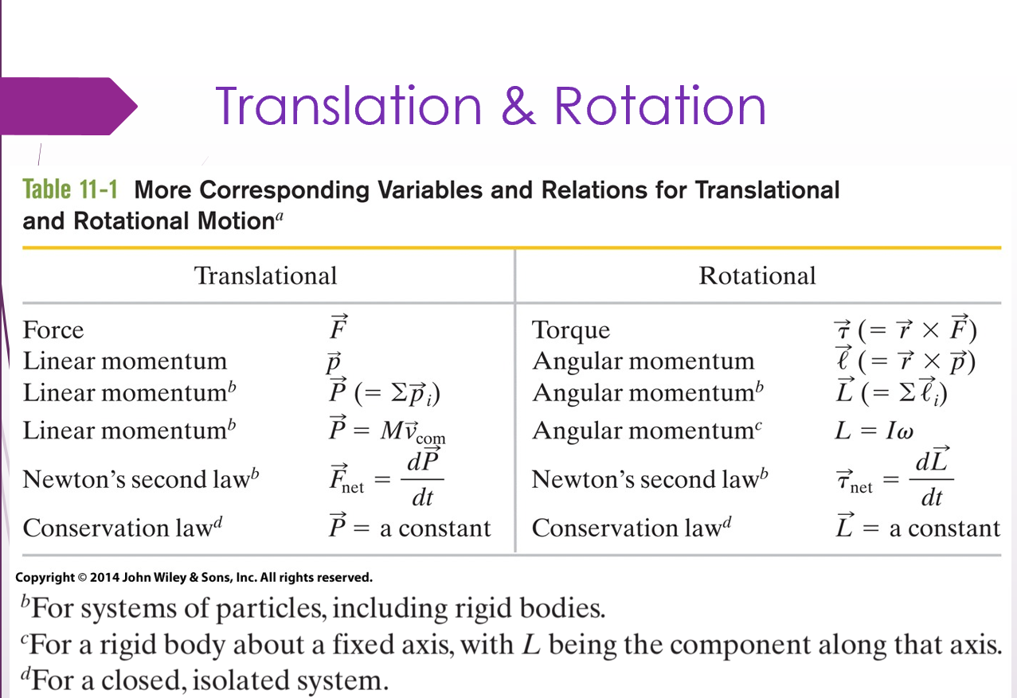
-Precession of a Gyroscope
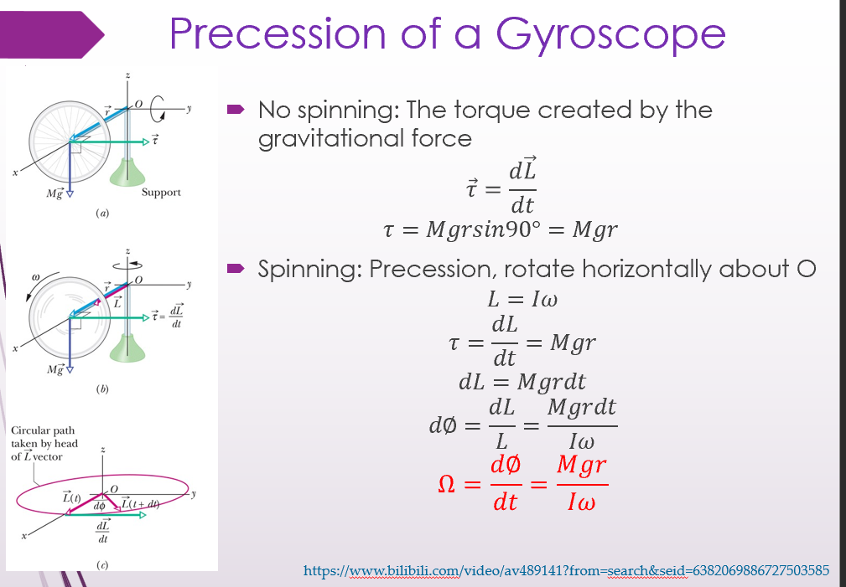
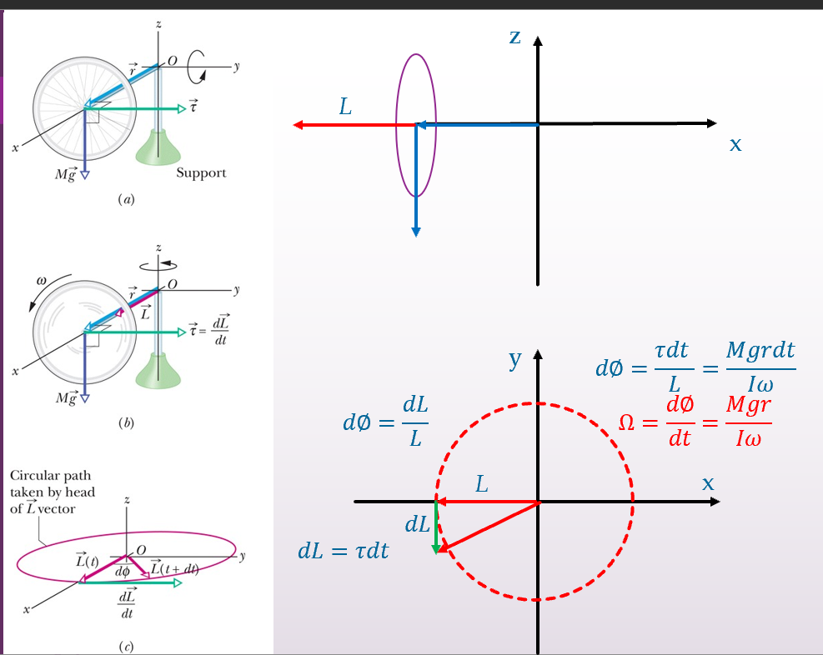
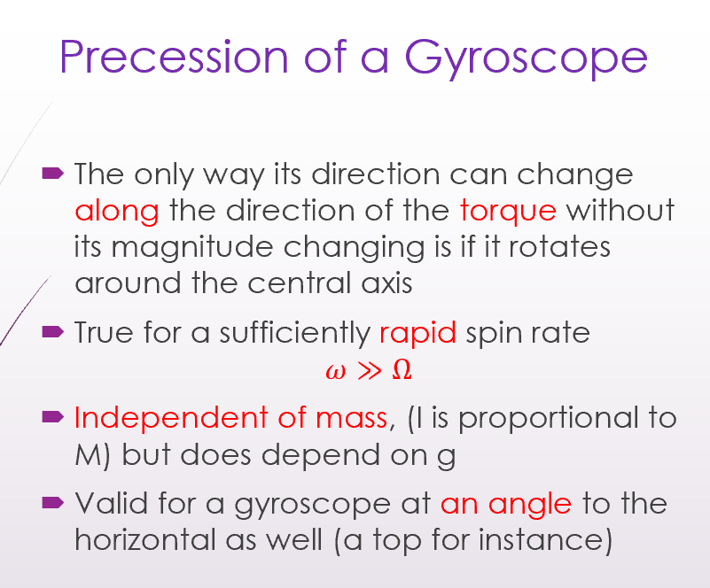

Ch12 Equilibrium and Elasticity
-Elasticity 弹性
Def.:
Describes how real bodies deform when forces are applied to them.
描述当对实体施加力时，它们如何变形。
The ability of an object or material to resume its normal shape after being stretched or compressed
是指物体或材料在拉伸或压缩后恢复正常形状的能力
Rigid body 刚体
No deformation(n.)形变 when forces applied to them 施加力时不变形
Doesn’t exist in reality
Elastic:
Deform - Return to its original shape
Rigid -Stiff interatomic springs:
Not stiff interatomic spring: loosely bound to its neighbors deform easily
当力作用在实体上时，实体可能会改变其尺寸的三种方式。
1. Tensile Stress 拉伸应力
2. Shearing stress 剪切应力
3. Hydraulic stress 液压应力
Modulus of Elasticity 弹性模量
$Stress=Modulus×strain$ $应力=模量 ×应变$
Stress(n.)应力 and Strain(n.)应变 are proportional to each other应力和应变彼此成正比
-Tension (n.)拉伸 & Compression (n.)压缩
Stress 应力
Def.: Force per unit Area $\frac{F}{A}$
Strain 应变
Def.: produced unit deformation 产生的单位形变 $\frac{∆L}{L}$
(ratio, dimensionless 是比率，没有量纲)
Young’s Modulus (E) 杨氏模量
$\frac{F}{A}=E\frac{∆L}{L}$ (应力 = E×应变)
SI-Unit 单位：N/m²

Stress vs. Strain Curves 应力与应变曲线
Yield Strenth 屈服强度
(是指材料在受到外力作用时，从弹性变形转变为塑性变形的临界点)
Stress < Yield Strength 当应力小于屈服强度时:
linear relationship, 应力与应变之间呈线性关系，
can recover after removal of the applied stress (Elastic Deformation)
当去除施加的应力后，材料可以恢复原状（弹性形变）。
Stress > Yield Strength 当应力大于屈服强度时:
Permanent deformation, cannot recover
材料会发生永久性变形，无法恢复
(plastic deformation 塑性形变)
Ultimate Strength 极限强度
Rupture/Fracture 材料发生断裂/破裂
may be different for Tension and compression 拉伸和压缩的极限强度可能不同
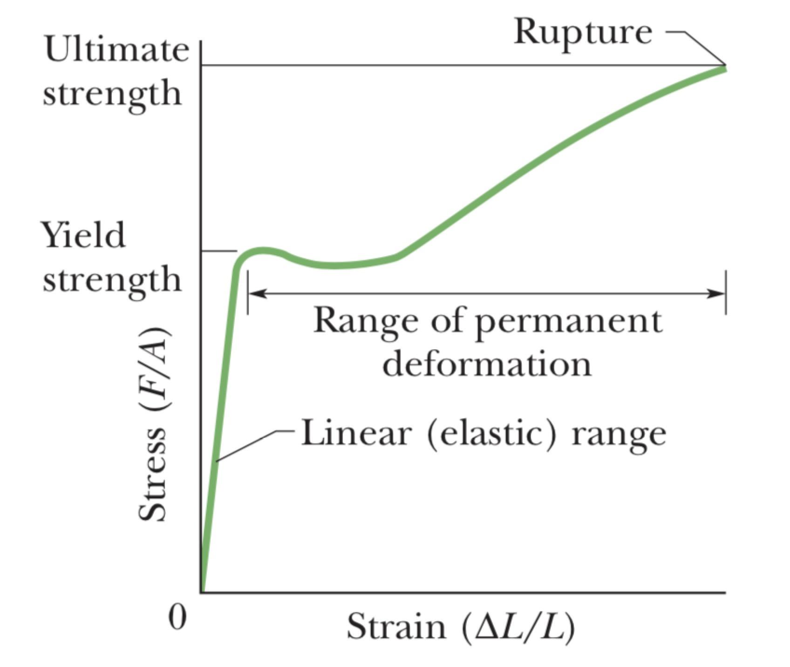
-Shearing 剪切
Stress 应力：$\frac{F}{A}$ Def.: The force lies in the plane of the area
Strain 应变：$\frac{∆x}{L}$
Shear Modulus (G) 剪切模量
$\frac{F}{A}=G\frac{∆x}{L}$ (应力 = G×应变)
SI-Unit 单位：N/m²
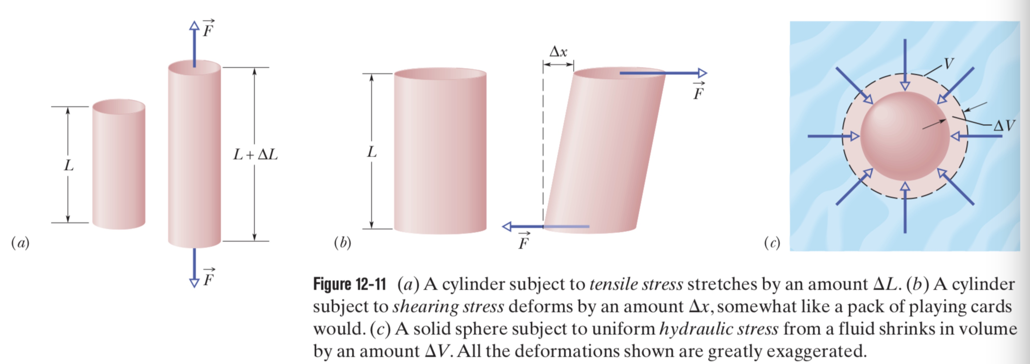
-Hydraulic Stress (p) 液压应力
Def.: fluid pressure on the object 物体上的流体压力

Strain 应变
$\frac{∆V}{V}$ Def.: absolute value of change in volume / original volume
Bulk Modulus (B) 体积模量
· $p=B\frac{∆V}{V}$
SI-Unit 单位: N/m²
(In general, solids – with their rigid atomic lattices – are less compressible than liquids, in which the atoms or molecules are less tightly couple to their neighbors.)
(一般来说，固体——具有刚性原子晶格——比液体更不可压缩，其中原子或分子与其邻居的耦合程度较低。)
-Equilibrium and Elasticity
Stability 稳定性
Def.: The equilibrium of forces and torques on rigid objects
刚体上力和扭矩的equilibrium平衡
& the elasticity of non-rigid body
非刚体的elasticity弹性
(The construction are supposed to be stable in spite of forces or torque acting on them)
(尽管有力或扭矩作用在结构上，结构应该是stable稳定的)
-Equilibrium 平衡
Equilibrium 平衡
Def.: $\vec{P}=constant$ and $\vec{L}=constant$
The linear Momentum of its COM is constant
The angular Momentum about its COM or about any other point , is also constant.
Static Equilibrium 静态平衡
Def.: $\vec{P}=0$ and $\vec{L}=0$
Not moving either in translation or in rotation
在平移或旋转中均不移动
Stable/ Unstable static equilibrium 稳定/不稳定静态平衡
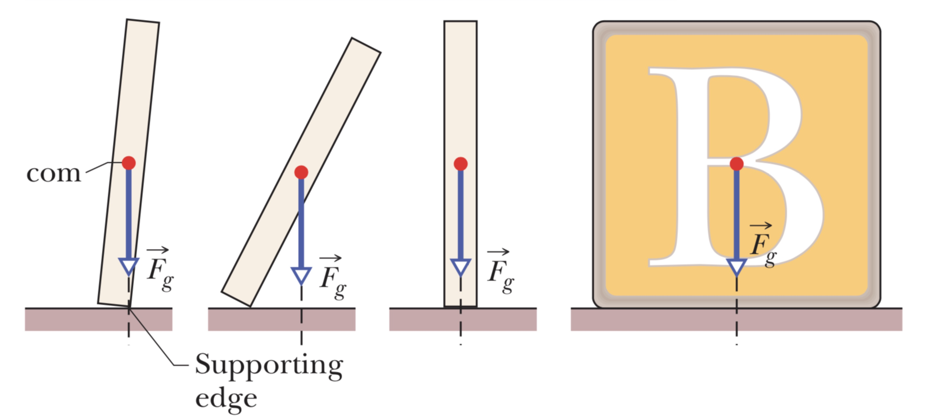
-Requirements of Equilibrium
Translational Equilibrium 平移平衡:
Balance of Forces 作用力平衡
$\vec{P}=constant$ → ${\vec{F}}_{net}=\frac{d\vec{P}}{dt}=0$
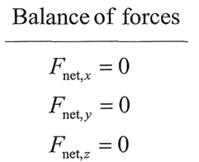
作用在物体上的所有外力的向量和必须为零
Rotational Equilibrium 旋转平衡:
Balance of Torques 力矩平衡
$\vec{L}=constant$ → ${\vec{τ}}_{net}=\frac{d\vec{L}}{dt}=0$
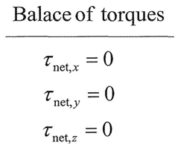
作用在物体上的所有外部扭矩的矢量和，measured about any possible point，必须为零
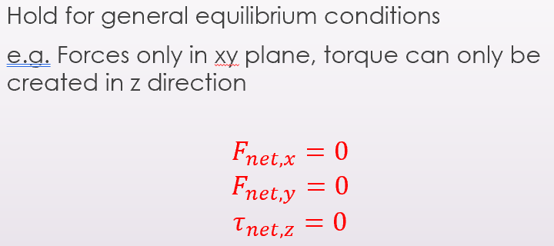
-The Center of Gravity 重心
Gravitational Forces 引力
Def.: the vector sum of the gravitational forces acting on the individual elements (the atoms) of the body
作用在物体的各个elements（atoms）上的引力的矢量和
Center of Gravity 重心
The gravitational Force ${\vec{F}}_{g}$ on a body effectively acts at a single point
如果物体的所有element的$\vec{g}$ 都相同，则$x_{cog}=x_{com}$
(center of gravity (cog) ; center of mass (com).)
(???) Proof: $τ=x_{cog}\sum{F_{gi}}=\sum{x_{i}F_{gi}}$ → $x_{cog}=\frac{1}{M}\sum{x_{i}m_{i}}=x_{com}$
(is coincident with 重合)

e.g. $F_{l}+F_{r}-Mg-mg=0$
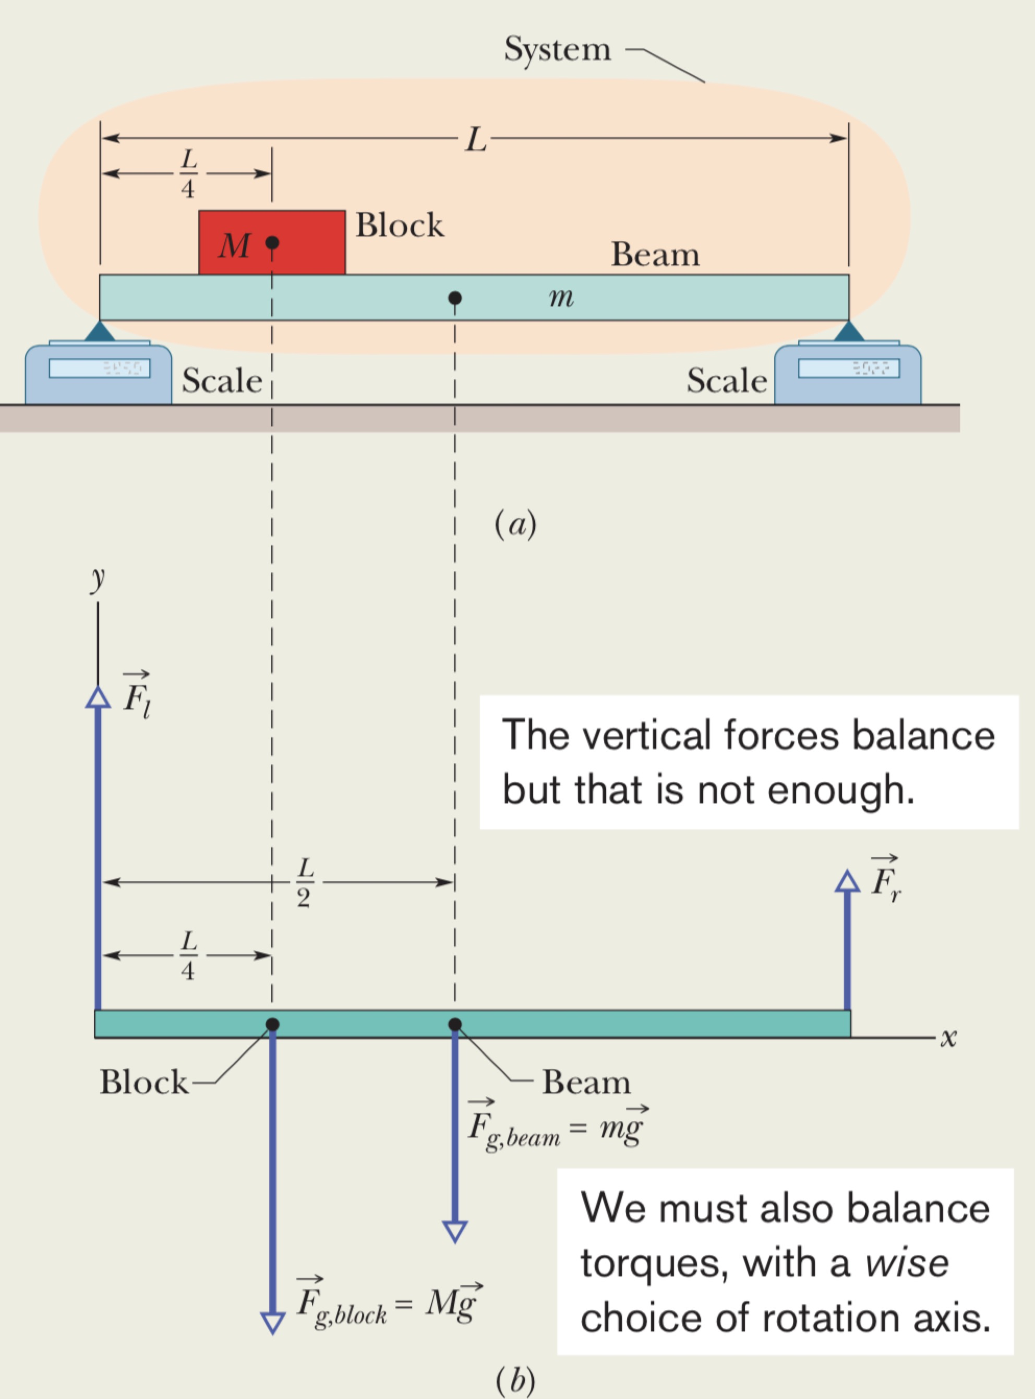
Strategy in the solution:
${\vec{τ}}_{net}=0$ & ${\vec{F}}_{net}=0$
在两个未知数的情况下，
(???) chose the rotational axis to消除扭矩方程的一个力
只剩下一个未知数，可以通过力平衡方程求解
e.g. $-{h F}_{w}+\frac{a}{2} Mg+\frac{a}{3}mg+0{ F}_{px}+0{ F}_{py} =0$
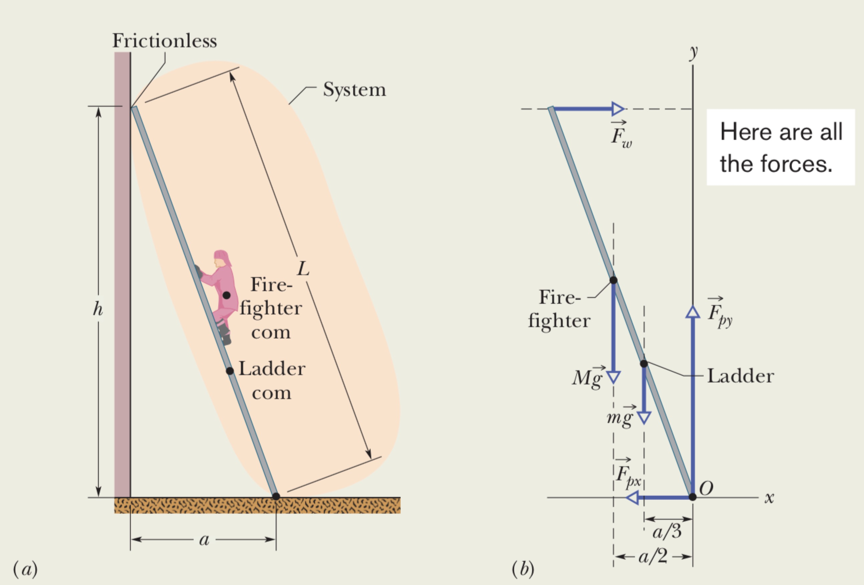 (??? O的选取 ???)
e.g. (设原点一次消除多个力矩)
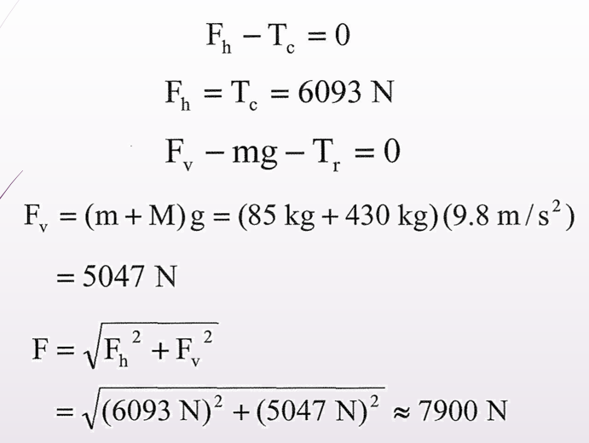 (通过力平衡方程求解)
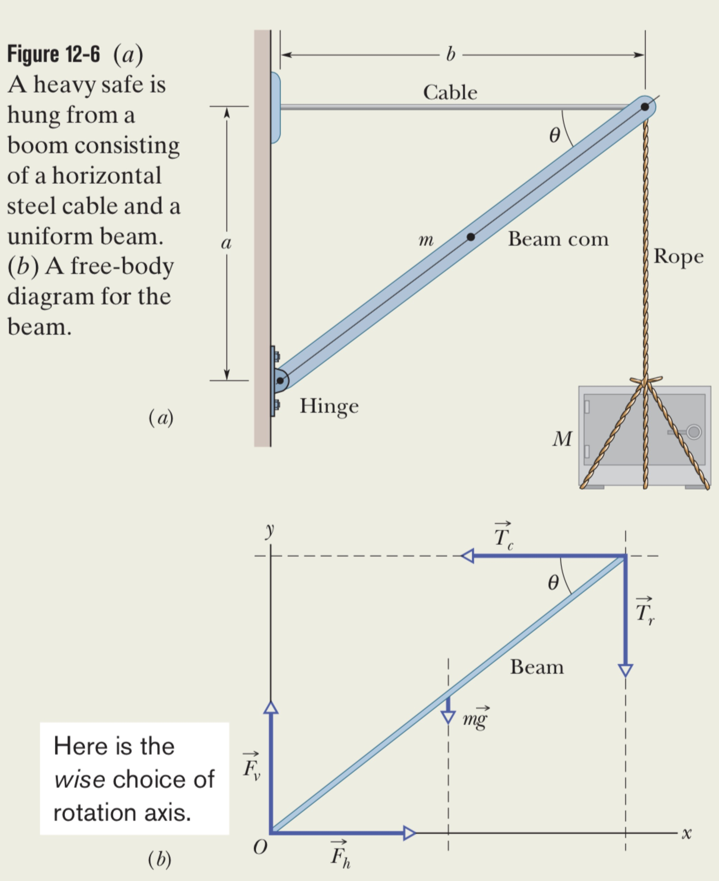
-Equilibrium in Non-Inertia Reference Frame 非惯性参考系中的平衡 (Additional Information)
Pseudo-Force虚假力(/惯性力)
Block A is accelerating ${\vec{a}}_{AG}$ towards right with respect to ground
Block P is acceleration ${\vec{a}}_{PG}$ with respect to ground,
and ${\vec{a}}_{PA}$ respect to A as well

· ${\vec{a}}_{PG}={\vec{a}}_{PA}+{\vec{a}}_{AG}$
→ $m_{P}{\vec{a}}_{PG}=m_{P}{\vec{a}}_{PA}+m_{P}{\vec{a}}_{AG}$
→ ${\vec{F}}_{I}={\vec{F}}_{NI}+m_{P}{\vec{a}}_{AG}$
→ ${\vec{F}}_{NI}={\vec{F}}_{I}-m_{P}{\vec{a}}_{AG}={\vec{F}}_{I}+{\vec{F}}_{o}$ (${\vec{F}}_{NI}={\vec{F}}_{I}+{\vec{F}}_{o}$)
→ ${\vec{F}}_{o}=-m_{P}{\vec{a}}_{AG}$
${\vec{F}}_{NI}$: Non-inertia force acting on the object 作用在物体上的非惯性力
${\vec{F}}_{I}$: Inertia Force 惯性力：物体由于其质量和加速度而产生的力
${\vec{F}}_{o}$: Pseudo Force 虚假力：在非惯性参考系中出现的力，用来解释物体的运动
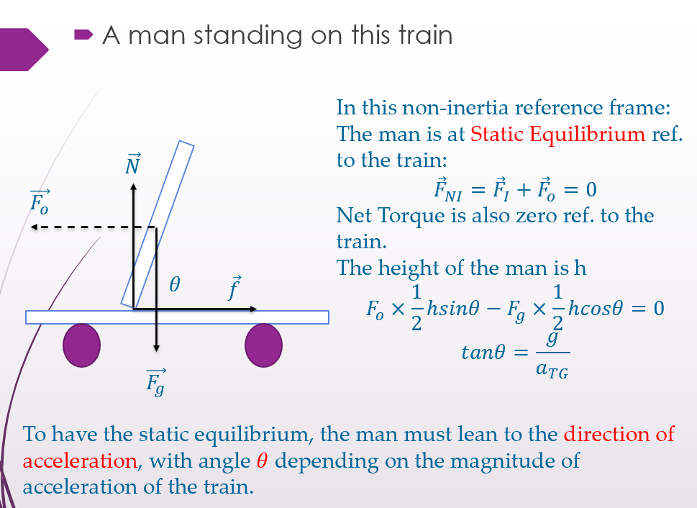
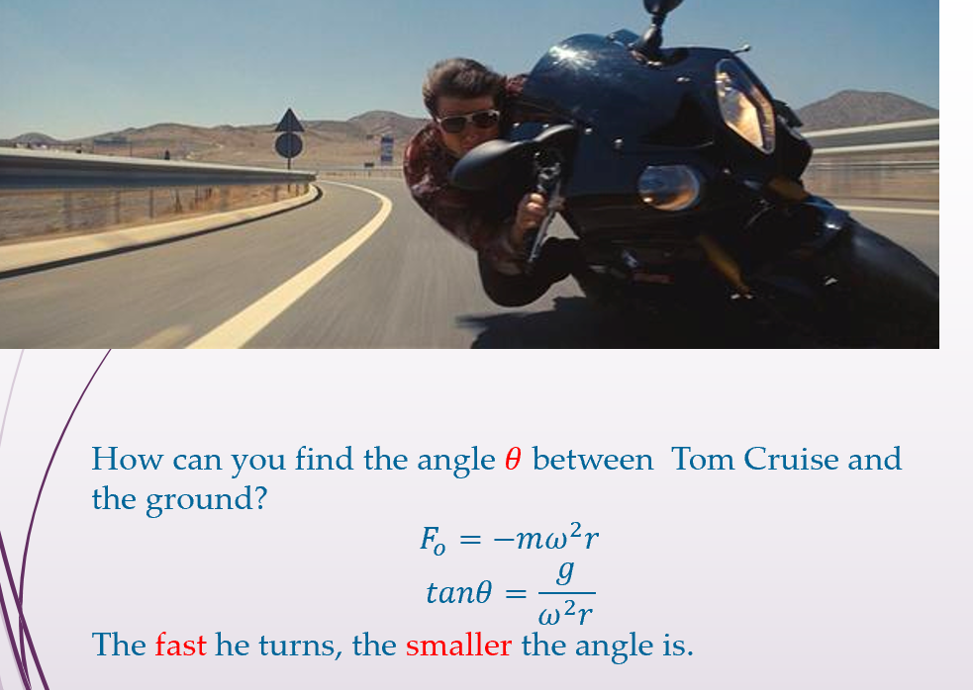

Ch13 Gravitation
-Gravitational Force
Black Holes
Def.: The gravitational force between all the particles can cause the star to collapse in on itself and thereby to form a black hole.
The G-Force at the surface is so strong that neither particles or light can escape from the surface.
-Newton’s Law of Gravitation 牛顿万有引力定律
Gravition
Def.: This tendency of bodies to move toward one another is called gravitation.
Newton’s force law between two particles (which has no size)
The magnitude of the gravitational force:
· $F=G\frac{m_{1}m_{2}}{r^{2}}$
𝐺: the Gravitational constant
$G=6.67×{10}^{-11} N∙{m^{2}}/{{kg}^{2}}$
$=6.67×{10}^{-11} {m^{3}}/{{kg∙s}^{2}}$
$m_{1}$ and $m_{2}$: the masses of each particle
$r$: the separation between the two particles
The gravitational force acting on Particle 1 due to particle 2:
· $\vec{F}=G\frac{m_{1}m_{2}}{r^{2}}\hat{r}$
$\hat{r}$: The radial unit vector:
a dimensionless vector of magnitude 1 along the r axis.

·Not altered by other objects, even if they are located in between. → Cannot Shield!
-Shell Theorem
A uniform spherical shell
(when attracts a particle that is outside the shell)
behave like a particle and the mass concentrated at the center
-Gravitation and Principle of Superposition
For n interacting particles,
the gravitational forces (vector sum) on particle 1:
(by principle of superposition)
${\vec{F}}_{1, net}={\vec{F}}_{12}+{\vec{F}}_{13}+{\vec{F}}_{14}+…+{\vec{F}}_{1n}=\sum_{i=2}^{n}{{\vec{F}}_{1i}}$
${\vec{F}}_{1, net}$: the net force on particle 1 due to the other particles
${\vec{F}}_{1n}$: the force on particle 1 from particle n)
(For a group of particles,
find the net (or resultant) gravitational force on any one of them
from the others)
↓
The gravitational force on a particle form a real (extended) object:
${\vec{F}}_{1}=\int{d\vec{F}}$ (If:a uniform sphere/a spherical shell: can use the shell theorem)
-Gravitation Near Earth’s Surface
gravitational acceleration $a_{g}=\frac{F}{m}=G\frac{M}{r^{2}}$
free-fall acceleration g: ${g≈a}_{g}$
differ from the $a_{g}$ for 3 reasons:
Earth’s mass is not uniformly distributed:
𝑔 varies from region to region over the surface
Earth is not a sphere: ellipsoid
If you moving at the sea level from the equator toward the north pole or south pole, 𝑔 increases since you are getting closer to the center of earth.
Earth is rotating:
Existence of centripetal acceleration
The difference between $g$and $a_{g}$
$F_{net},r=ma_{r}=mg=ma_{g}-mω^{2}R$
→ $g=a_{g}-ω^{2}R$
(Free-fall acceleration = gravitational acceleration – centripetal acceleration)
$ω^{2}R={(\frac{2π rad}{24×3600 s})}^{2}×6.37×{10}^{6} m=0.034 m/s^{2}$ << $g=9.8 m/s^{2}$
(neglecting the difference between
weight($mg$) and the magnitude of the gravitational force($ma_{g}$)
is also often justified.)
-Gravitation Inside Earth
A uniform shell of matter exerts no net gravitational force on a particle located inside it.
& The $F_{g}$ doesn't disappear → vectors’ sum is ZERO!
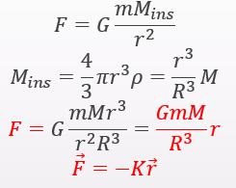
-Gravitation Potential Energy
$U=mgy$
For a two-particle system: $U=-\frac{GMm}{r}$;
对于多个粒子，依次考虑每对粒子。计算该对的U，就好像其他粒子不存在一样。$U=-(\frac{Gm_{1}m_{2}}{r_{12}}+\frac{Gm_{1}m_{3}}{r_{13}}+\frac{Gm_{2}m_{3}}{r_{23}})$
Proof of U:
$W=\int_{R}^{∞}{\vec{F}\left(r\right)}∙d\vec{r}=\int_{R}^{∞}{F\left(r\right)dr\cos{∅}}=-\int_{R}^{∞}{F\left(r\right)dr}$
$=-\int_{R}^{∞}{\frac{GMm}{r^{2}}dr}=-GMm\int_{R}^{∞}{\frac{1}{r^{2}}dr}=-\frac{GMm}{R}$
$∆U=-W$
→ $∆U=U_{∞}-U=0-U=-W$
($U=W=-\frac{GMm}{R}$)
- Potential Energy and Force
$F=-\frac{dU}{dr}=-\frac{d}{dr}\left(-\frac{GMm}{r}\right)=-G\frac{Mm}{r^{2}}$: The –ve sign indicate the force on mass m points radially inward, toward mass M
-Escape Speed
(Earth) escape speed $v$.
$K_{surface}+U_{surface}=K_{infinite}+U_{infinite}=0+0=0$
$\frac{1}{2}mv^{2}+\left(-\frac{GMm}{R}\right)=0$
$v=\sqrt{\frac{2GM}{R}}$
v不依赖于从行星发射弹丸的方向。如果弹丸在行星绕轴旋转时向发射场移动的方向发射，则更容易达到此速度。 → 利用地球的自转速度
-Kepler’s Laws
1. 质量为m的行星在围绕太阳M为焦点的椭圆轨道上移动。
(For Earth’s orbit, 𝑒=0.0167)
2. 等价于角动量守恒定律: 连接行星和太阳的线以相等的时间间隔扫除行星轨道平面相等面积: dA/dt 是恒定的。
$∆A≈\frac{1}{2}r·r∆θ=\frac{1}{2}r^{2}∆θ$; (L与dA/dt同为常数)
角动量$L=rp_{⊥}=rmv_{⊥}=rm\left(ωr\right)=mr^{2}ω$
→ $\frac{dA}{dt}=\frac{1}{2}r^{2}ω=\frac{L}{2m}$ (是连线的$ω$)
semimajor axis半长轴 (a)
eccentricity离心率 (e)
3. planetary orbit—period周期: $T^{2}=\frac{{4π}^{2}}{GM}r^{3}$
卫星: 动能$K=\frac{1}{2}mv^{2}=\frac{GMm}{2r}$; (circular orbit)
(总)机械能 $E=K+U=-\frac{GMm}{2r}=-K$
elliptical orbit椭圆轨道(半长轴为a) 上的卫星 的机械能: $E=-\frac{GMm}{2a}$
Principle of Equivalence等效原理: Gravitation and acceleration are equivalent. (?)

Ch14 Fluid
-(Def.:???) a substance that can flow.
1. Fluids conform to the boundaries of any container in which we put them.
Because: a fluid cannot sustain a force that is tangential to its surface.
流体不能承受与其表面相切的力。
(It cannot withstand a shearing stress.)（它不能承受剪切应力。）
(Some materials (pitch) take a long time to conform to a container but are still fluids.)
2. It can exert a force in the direction perpendicular to its surface.
3. Don’t have long-range crystalline lattice. 没有长程晶格。
-Density (ρ)密度
Def.: $ρ=\frac{∆m}{∆V}$ ; Uniform Density: $ρ=\frac{m}{V}$
Is a scalar with no direction.
-Pressure (p) 压强
Def.: $p=\frac{∆F}{∆A}$ ; If the force is uniform over a flat area A: $p=\frac{F}{A}$
无论方向，value值 都相同
Is a scalar with no direction: only involve the Magnitude of the Force.
SI-Unit 单位: pascal -- 1 N/m² = 1 Pa
一个大气压强 $1 atm=1.01×{10}^{5}Pa=760 torr=14.7 lb/{in}^{2}$
(Torr is one of the widely used units是广泛使用的单位之一: 1 torr = 1 mm Hg)
Pressure Sensor 压力传感器: 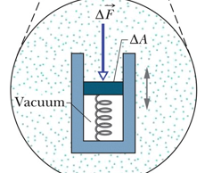
-Fluid at Rest 静止时的液体
The Hydrostatic pressure are those caused by fluids at rest (air in the atmosphere, water in a tank) 静水压力是由静止的流体（大气中的空气，水箱中的水）引起的压力
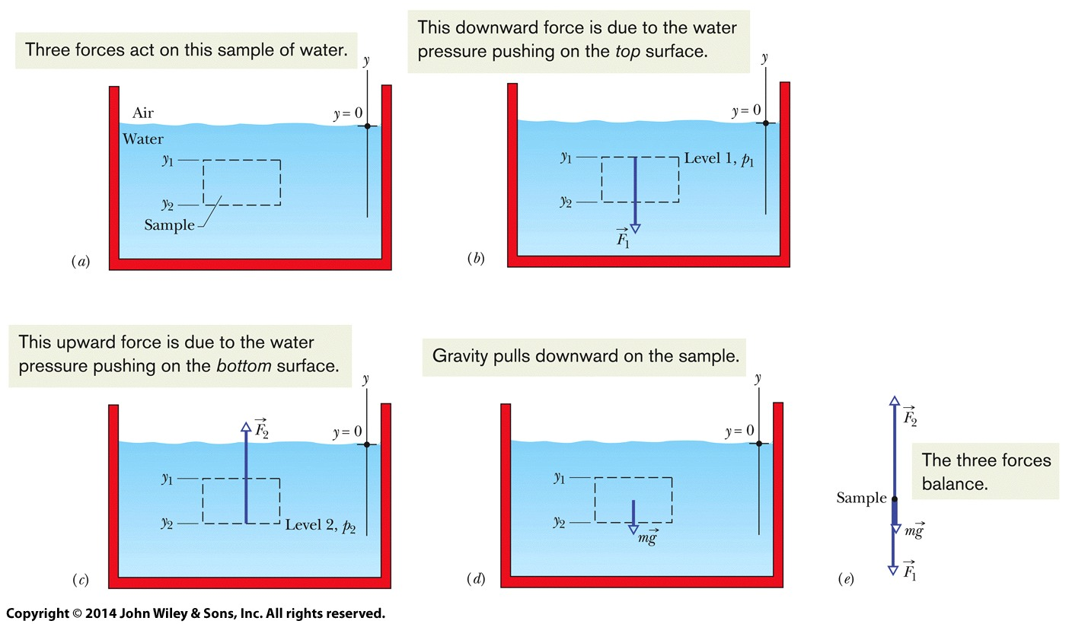
The water is in static equilibrium: $F_{2}=F_{1}+mg$ ; ($F_{1}=p_{1}A$ ; $F_{2}=p_{2}A$)
→Therefore: $p_{2}A=p_{1}A+mg=p_{1}A+ρAg(y_{1}-y_{2})$
↓$p_{2}=p_{1}+ρg(y_{1}-y_{2})$
→$p=p_{0}+ρgh$
The pressure at a point in a fluid in static equilibrium
depends on the depth of that point
but not on any horizontal dimension of the fluid or its container.
处于 static equilibrium静态平衡 的流体中某一点的压力 取决于该点的depth深度，
但 不取决于 流体或其容器的任何水平尺寸
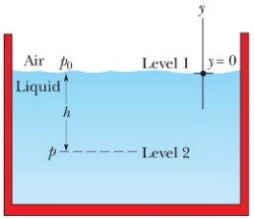
any horizontal dimension of the fluid or its container
Absolute pressure (p) 绝对压强！
For atmospheric pressure: $p=p_{0}-ρ_{fluid}gd$
consists of two contributions:
p₀: The pressure due to atmosphere 大气压强(通常是海平面处的(?))
𝜌_{fluid} g h: The gauge pressure表压 : (以上fluid为air)
Def.: the difference between an absolute pressure and an atmospheric pressure 绝对压强 与 大气压强 之差 (指相对于大气压的压力差)
(d: The distance above level 1)
（由于空气受重力作用，空气密度随高度增加而减小，因此气压也随高度增加而减小，因此此公式中使用减号(-)，但是果是计算液体内某一深度处的绝对压强，那么应该使用加号(+)）

-Measuring Pressure 测量压力
Mercury Barometer 水银气压计
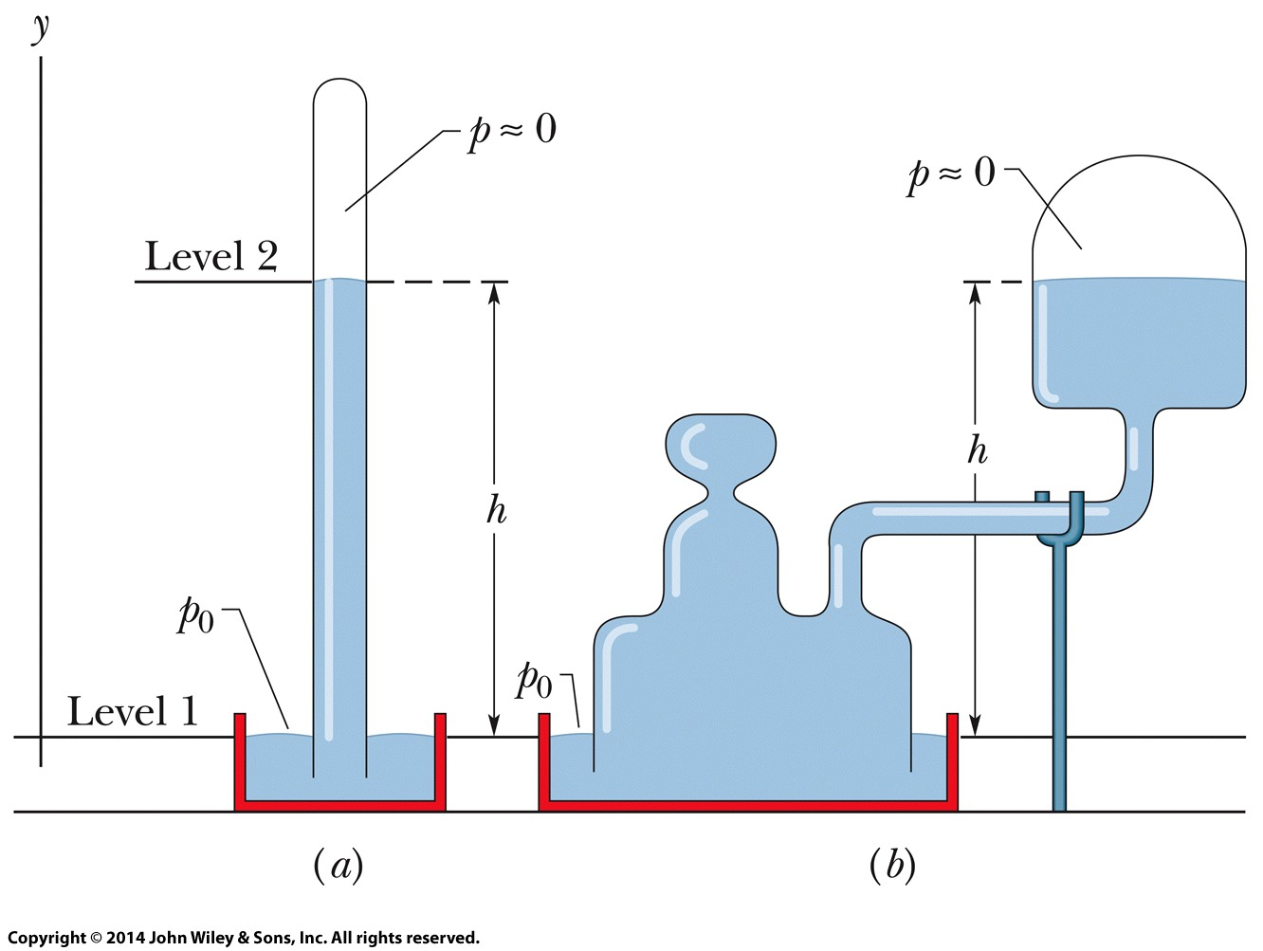
大气压 $p_{0}=ρgh$
𝜌: density of mercury
h: the height difference between air-mercury interface and the mercury level
p₀ Independent of the cross-sectional area
h: is numerically equal to torr pressure
only if Barometer is at a place where g has its standard value (9.80665 m/s2)
and Temperature of mercury is 0°C
仅当 g为标准值 且 温度T=0℃ 时，h在数值上 等于 torr pressure
-The Open-Tube Manometer 开管压力计
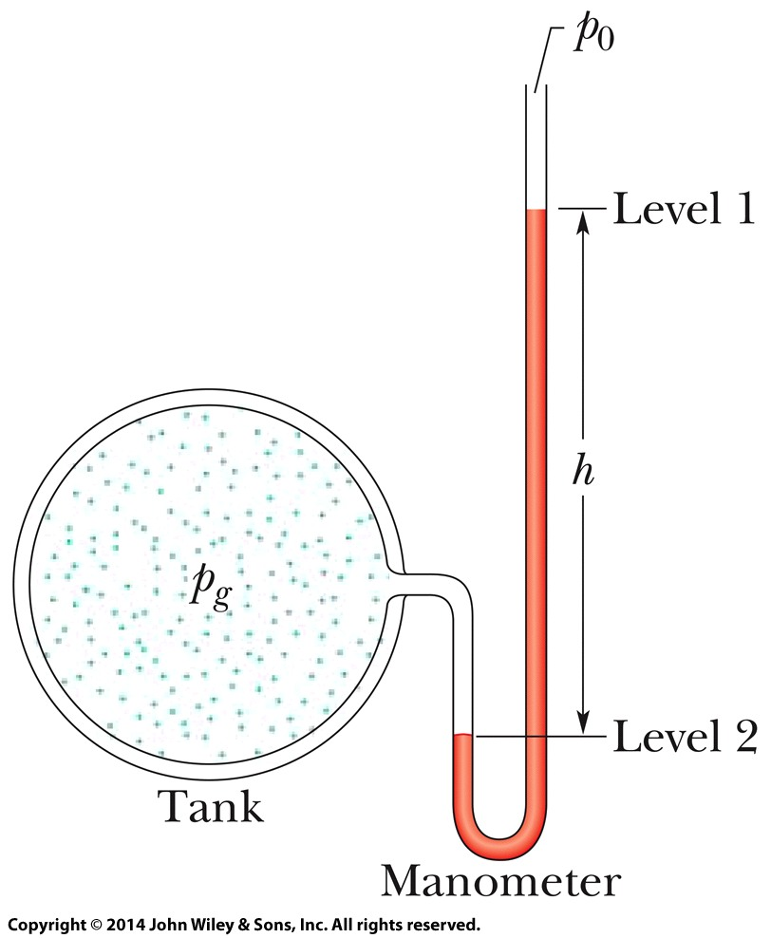
Measure the gauge pressure ($p_{g}$) of gas 测量气体的gauge pressure表压
$p_{g}=p-p_{0}=ρgh$
𝜌: Liquid Density
1. p_{g}与h成正比
2. p_{g}可正可负：取决于p与p₀的相对大小
-Pascal’s Principle 帕斯卡原理
govern (v.)治理
Governs the transmission of pressure through an incompressible fluid
控制 不可压缩流体 的 压力的传递
A change in the pressure applied to an enclosed incompressible fluid
施加在封闭的不可压缩流体上的 压力的变化
is transmitted undiminished to every portion of the fluid and to the walls of its container.
会毫不减弱地 传递到 流体的每个部分 及其 容器壁。
The pressure at any point in the liquid (p):
$p=p_{ext}+ρgh$
→$∆p=p-ρgh=p_{ext}$ : The pressure change is independent of h
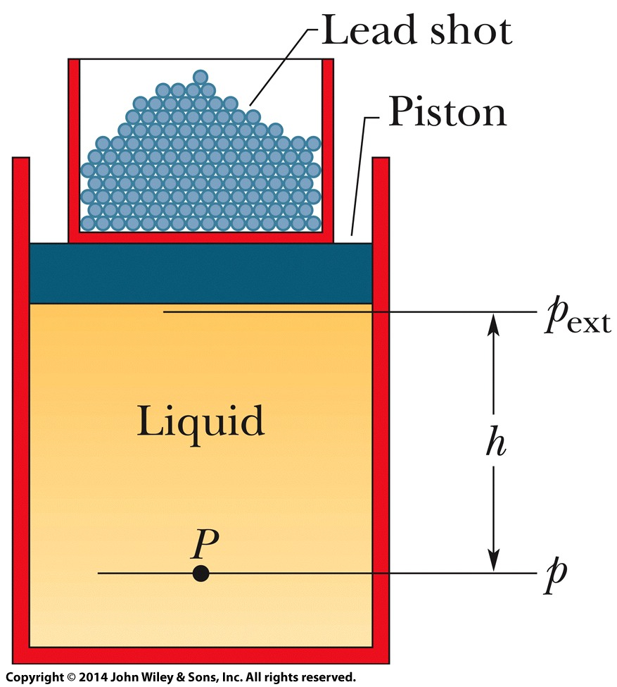

e.g. -Hydraulic Lever 液压杆
使用液压杆，在给定距离上 施加的 给定力
可以转换为 在较小距离上 施加的 更大力
· $∆p=\frac{F_{i}}{A_{i}}=\frac{F_{o}}{A_{o}}$
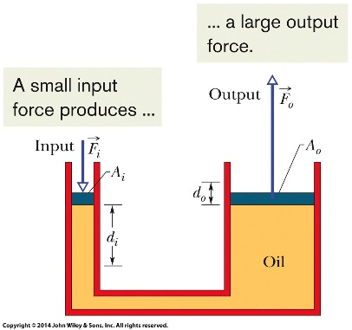
→ $F_{o}=F_{i}\frac{A_{o}}{A_{i}}$
· $V=A_{i}d_{i}=A_{o}d_{o}$
→ $d_{o}=d_{i}\frac{A_{i}}{A_{o}}$
→ $W=F_{o}d_{o}=F_{i}\frac{A_{o}}{A_{i}}×d_{i}\frac{A_{i}}{A_{o}}=F_{i}d_{i}$
-Archimedes’ Principle 阿基米德原理
Buoyant force 浮力
Def.: the net upward force on a submerged object by the fluid in which it is submerged
流体 对 浸没在其中 的 物体 的 净向上力
comes from the increase in pressure with depth
来自 压力 随深度 的 增加
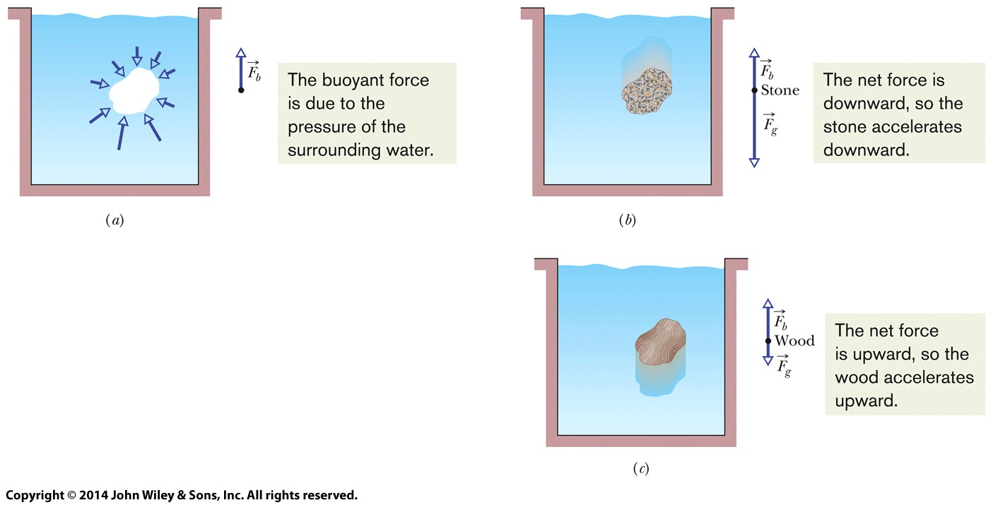
当物体完全或部分浸没在流体中时，来自周围流体的浮力${\vec{F}}_{b}$作用在物体上。
力是向上的，其大小等于 被物体置换的流体的重量$m_{f} g$。
The buoyant force on a body: $F_{b}=m_{f} g$

-Floating 漂浮
When a body floats in a fluid,
$F_{b}=F_{g}=m_{f}g$
-Apparent Weight 表观重量 in a Fluid
${weight}_{app}=weight-F_{b}$
(apparent weight表观重量) = (actual weight实际重量) – (buoyant force浮力)
-Ideal Fluids in Motion
4 Assumptions about ideal fluid 关于 理想流体 的 4个假设:
Steady Flow, Incompressible Flow, Nonviscous Flow, Irrotational Flow
稳态流、不可压缩流、非粘性流、无旋流
1. Steady Flow 稳态流:
The velocity of the moving fluid at any fixed point doesn't change with time
任何固定点的 移动流体 的 速度 不随时间变化
2. Incompressible Flow 不可压缩流:
As for fluids at rest,
that our ideal fluid is incompressible;
that is, its density has a constant, uniform value.
静止的理想流体 : 是不可压缩的: 密度是恒定的、均匀的
3. Nonviscous Flow 非粘性流:
No viscous drag force 没有粘性阻力
↓ Viscosity of a fluid is a measure of how resistive the fluid is to flow
↓ 流体的粘度 是 衡量 流体流动阻力 的 量度
No resistive force due to viscosity 没有由于粘性而产生的阻力。
4. Irrotational Flow 无旋流:
In irrotational flow, the test body
may (or may not) moves in a circular path,
will not rotate about its COM. (like Ferris Wheel)
在无旋流中，试验物体:
· 可能沿着圆形轨迹移动
· 可能不移动
但它不会绕着其质心旋转（就像摩天轮一样）。
( 无旋流（Irrotational flow）是指流体中任意一点的旋度都为零的流动，这意味着流体中的任何一点都没有局部旋转。在这种流动中，流体微团不会绕着自己的质心旋转。因此，在上面这句话中，即使试验物体沿着圆形轨迹移动，它也不会绕着自己的质心旋转。 )

(粘度（Viscosity）
是流体内部阻力的一种度量，表示流体内部层与层之间的摩擦力。
粘性（Viscosity）
是指流体内部分子之间的粘附力，它是导致流体粘度的原因。
简单来说，粘度是流体的一种物理性质，而粘性是导致这种性质的原因。
在英文中，粘度和粘性都可以用 Viscosity 来表示。 )
-Streamline (n.)流线 ( , (adj.)流线型(的) )
Def.: the path that a tiny element of the fluid would take as the fluid flows.
流体流动时，流体微团所经过的路径
· The direction of the velocity is tangent to a streamline. (流体的)速度的方向与流线相切
· Two streamlines can never intersect.( (任意)两条流线 永不 相交)
(如果两条流线相交，
在它们交叉点的元素将同时具有两个不同的速度：这是不可能的。)
-The Equation of Continuity
Incompressible flow: the volume flow rate through any cross-section must be constant
$$∆V=A_{1}v_{1}∆t=A_{2}v_{2}∆t$$
Equation of Continuity:
$$A_{1}v_{1}=A_{2}v_{2}$$
Volume Flow Rate $R_{V}$
$$R_{V}=Av=a constant$$
Volume past a given point per unit time
SI-unit: m³/s
Mass Flow Rate $R_{m}$
$$R_{m}=ρAv=a constant$$
SI-unit: kg/s

-Bernoulli’s Equation
Ideal fluid flows at a steady rate
· $p_{1}+\frac{1}{2}ρv_{1}^{2}+ρgy_{1}=p_{2}+\frac{1}{2}ρv_{2}^{2}+ρgy_{2}$
Fluid’s Kinetic energy density:
· $\frac{1}{2}ρv^{2}$
Bernoulli’s Equation
· $p+\frac{1}{2}ρv^{2}+ρgy=constant$
If $v_{1}=v_{2}=0$
· $p_{2}=p_{1}+ρg{(y}_{2}-y_{1})$
If $y_{1}=y_{2}$
· $p_{1}+\frac{1}{2}ρv_{1}^{2}=p_{2}+\frac{1}{2}ρv_{2}^{2}$
-Lift of Airplane
$p+\frac{1}{2}ρv^{2}+ρgy=constant$
smaller air pressure, faster air speed

Ch15 Oscillations
-Oscillation 振动
Def.: Any motion that repeats itself in a periodic manner
(Objects move back and forth repeatedly)
e.g. Pendulum (n.)单摆
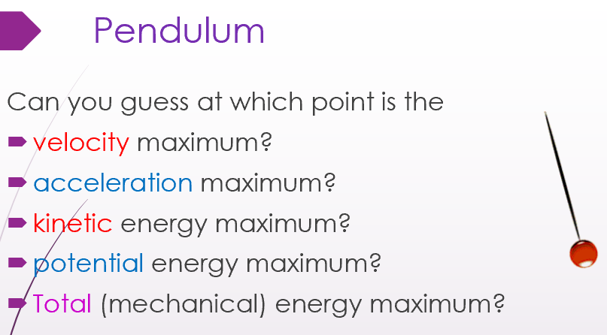
The particle oscillating about the origin of an x axis,
repeatedly going left and right by identical amount.
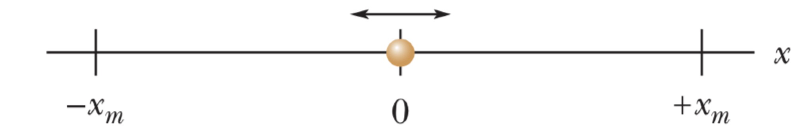
Frequency (f) 频率
Def.: the number of times per second that it completes a full oscillation (a cycle).
Unit: Hz (赫兹) ($1 hertz=1 Hz=1 oscillation per second=1 s^{-1}$)
Period (T) 周期
Def.: the time for one full cycle
Unit: s (秒)
· $T=\frac{1}{f}$
-Simple Harmonic Motion (SHM) 简谐运动
Def.: the motion is a sinusoidal function正弦函数 of time t
(可能可写为sine/cosine函数的形式)
the motion of a particle
when the force acting on it
is proportional to the particle’s displacement but in opposite direction.
(作用在粒子上的力 与 粒子的位移 成正比 但 方向相反 时粒子的运动。)
Displacement (or position) function 位移函数: (with respect to time t)
$x\left(t\right)=x_{m}\cos\left(ωt+∅\right)$ or $x\left(t\right)=x_{m}sin⁡(ωt+∅)$
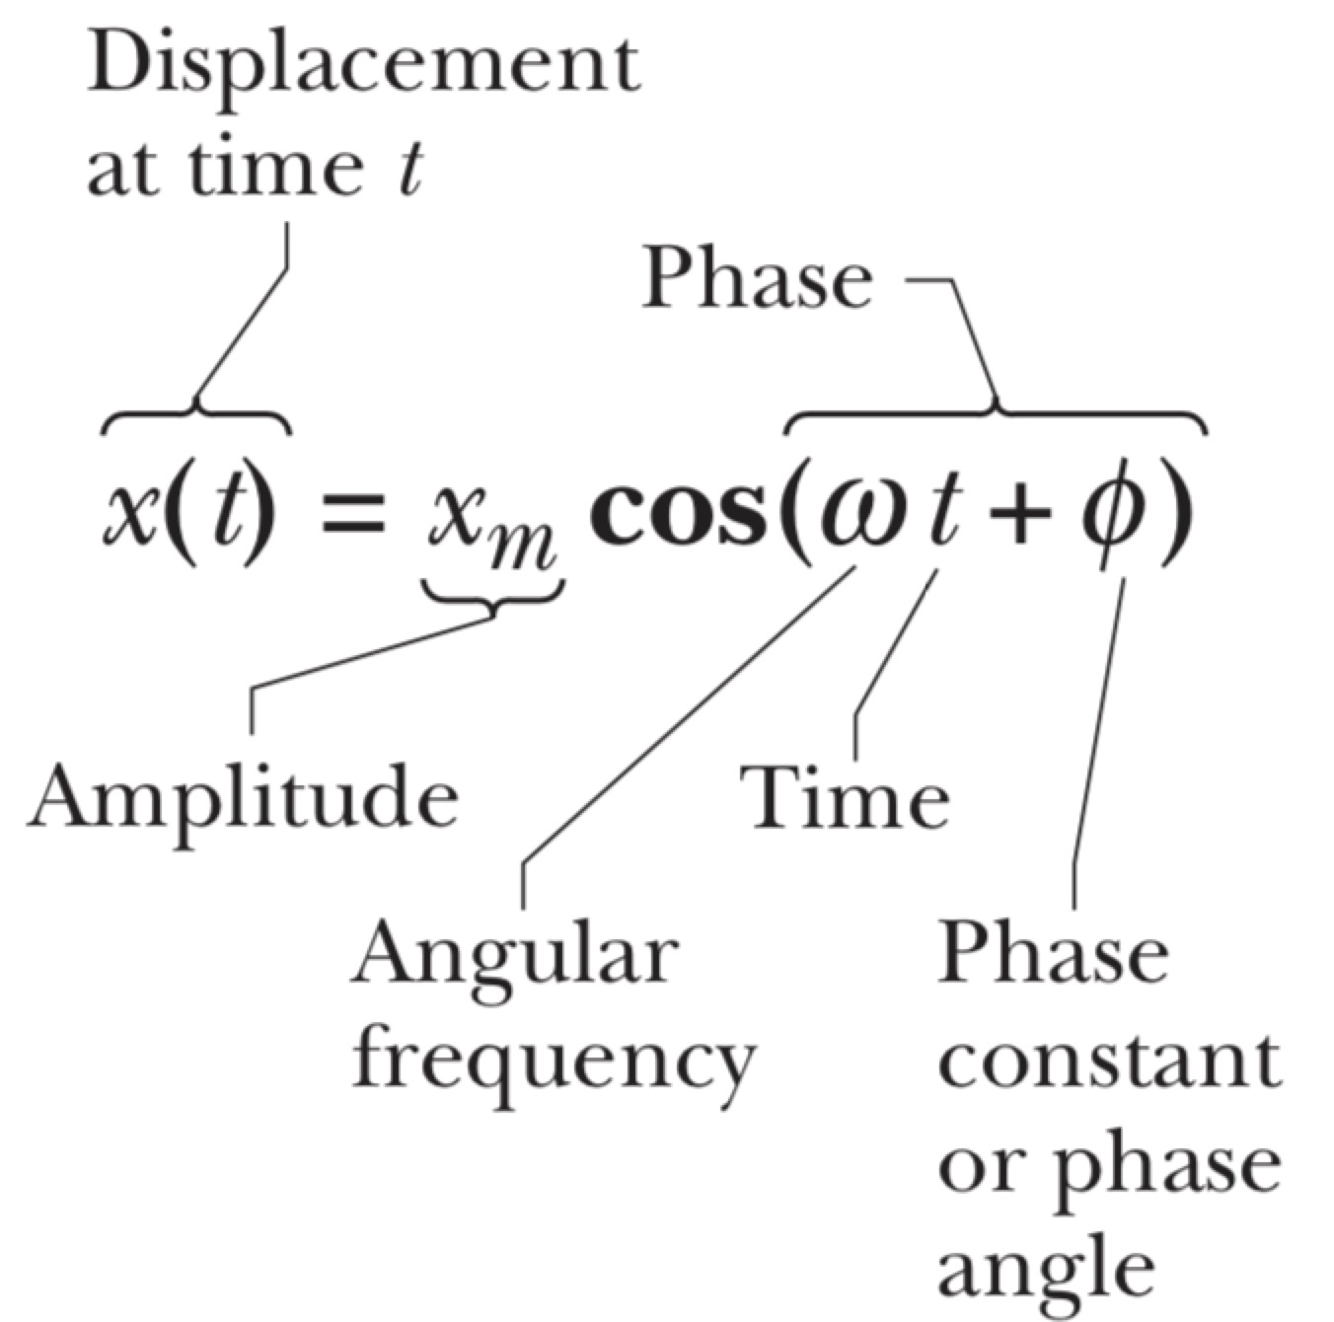
Amplitude振幅 ($x_{m}$)
The maximum distance of displacement from the equilibrium point
距平衡点的最大位移距离
Unit: m
Angular Frequency角频率 (𝜔)
(Related with Period of Motion T)
$ω=\frac{2π}{T}=2πf$
Unit: rad/s
Phase constant相位常数 ($∅$)
Depends on initial condition
(e.g., When t=0, if $x=x_{m}$, then $∅=0 rad$)
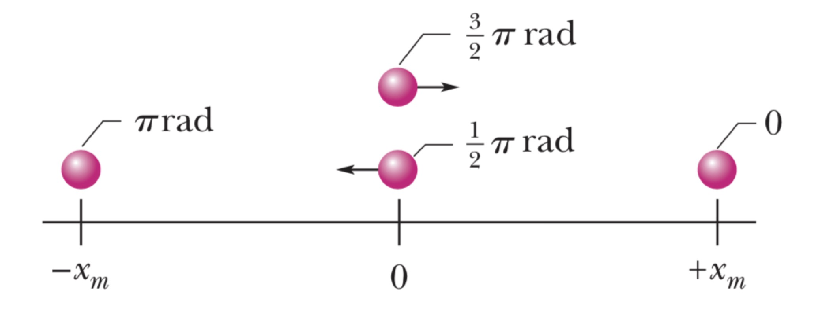
Unit: rad
Phase 相位 ($ωt+∅$)
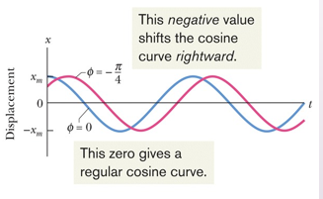
The Velocity of SHM
(!! varies in magnitude and direction !)
Velocity as a function of t:
· $v\left(t\right)=\frac{dx\left(t\right)}{dt}$
· $=\frac{d}{dt}[x_{m}cos⁡(ωt+∅)]$
· $={-ωx}_{m}sin\left(ωt+∅\right) ( ={-v}_{m}\sin\left(ωt+∅\right) )$
$v_{m}={ωx}_{m}$: Velocity amplitude
( The phase shift of the velocity is π/2,
making the cosine to a negative sine function )
When 𝑥=0, the speed v is maximized.
The Acceleration of SHM
(!! varies in magnitude and direction !)
Acceleration as a function of t:
· $a\left(t\right)=\frac{dv\left(t\right)}{dt}$
· $=\frac{d}{dt}[{-ωx}_{m}sin⁡(ωt+∅)]$
· $=-ω^{2}x_{m}cos\left(ωt+∅\right) ( ={-a}_{m}\cos\left(ωt+∅\right) )$
· $=-ω^{2}x(t)$
(The dynamical equation of the particle is $\frac{d^{2}x}{dt^{2}}+ω^{2}x=0$)
$a_{m}=ω^{2}x_{m}$: Acceleration Amplitude
( The phase shift of the acceleration is π,
making the cosine to a negative cosine function )
The particle’s acceleration a(t) always opposite its displacement x(t)
(The magnitude of 𝑎 and 𝑥 are always related by a constant 𝜔^2)
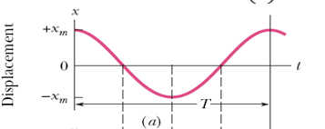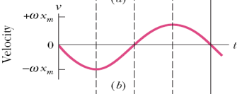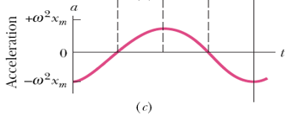 ($∅=0$)
-The Force Law for SHM
Newton’s 2nd Law & Hooke’s Law
The restoring force 回复力 of the particle：
· $F=ma = -mω^{2}x=-kx$ ($k=mω^{2}$)
SHM: 作用在粒子上的力 与 粒子的位移 成正比 但方向相反
· $k=mω^{2}$ :
$ω=\sqrt{\frac{k}{m}}$ $T=2π\sqrt{\frac{m}{k}}$
→ k↑，𝜔↑，T↑
Proof:
Let $x=Ae^{i(ωt+∅)}$ ($e^{iθ}=cosθ+i sinθ$) ($A=x_{m}$)
→ $v\left(t\right)=\frac{dx}{dt}=iωAe^{i(ωt+∅)}$
→→ $a\left(t\right)=\frac{d^{2}x}{dt^{2}}=-ω^{2}Ae^{i(ωt+∅)}$
Put it back to $ma+kx=m\frac{d^{2}x}{dt^{2}}+kx=0$:
$-ω^{2}Ae^{i\left(ωt+∅\right)}×m+kAe^{i\left(ωt+∅\right)}=0$
→ $ω=±\sqrt{\frac{k}{m}}$ →→ $ω=\sqrt{\frac{k}{m}}$

Linear simple harmonic oscillator 线性简谐振子
Linear : indicates that: $F$ is proportional to $x$ to the first power
F与x的一次幂成正比 ($F=ma=-kx =-mω^{2}x$)
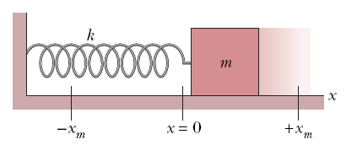
-Energy in SHM
The potential energy of a linear oscillator SHM中的 势能:
$U\left(t\right)=\frac{1}{2}kx^{2}$
$=\frac{1}{2}kx_{m}^{2} \cos^{2}\left(ωt+∅\right)$ (associated entirely with the spring)
is maximized
when the block is at full extension of the spring
($ωt+∅=±k π$)

The kinetic energy of a linear oscillator SHM中的 动能:
$K\left(t\right)=\frac{1}{2}mv^{2}$
$=\frac{1}{2}mω^{2}x_{m}^{2}\sin^{2}\left(ωt+∅\right)$
$=\frac{1}{2}kx_{m}^{2}\sin^{2}\left(ωt+∅\right)$
is maximized
when the block is moving through the mid-point of the oscillation
($ωt+∅=±k π/2$)

The mechanical energy of a linear oscillator SHM中的 机械能:
$E=U\left(t\right)+K\left(t\right)$
$=\frac{1}{2}kx_{m}^{2}\left[\cos^{2}\left(ωt+∅\right)+\sin^{2}\left(ωt+∅\right)\right]$
$=\frac{1}{2}kx_{m}^{2}$
The Total Energy is Conserved ($E=\frac{1}{2}kx_{m}^{2}$)
仅取决于初始条件（k和x_{m}）
Only conservative forces present,
hence the total energy is conserved.
SHM中，只有守恒力，因此能量守恒
-Rules to Distinguish SHM
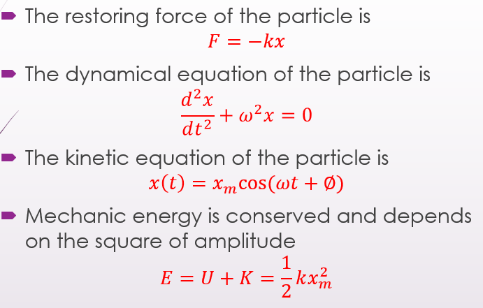
-Angular Simple Harmonic Oscillator 角谐振子
Torsion Pendulum 扭摆
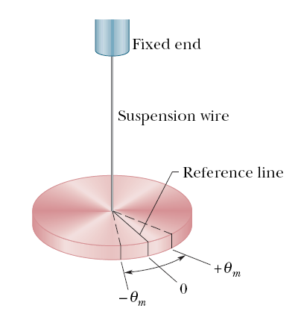
with a suspension wire instead of a spring
rotate the disk by some angular displacement 𝜃
from its rest position and release it,
it will oscillate about that position in angular simple harmonic motion
Restoring Torque (τ) 回复力矩
$τ=-κθ$
𝜅: Torsion constant 扭转常数
depends on the length, diameter, and material
取决于(wire)长度、(disk)直径、(disk)材料
-Angular Simple Harmonic Motion 角谐振子运动
$T=2π\sqrt{\frac{I}{κ}}$ ($ω=\sqrt{\frac{κ}{I}}$) (Similarly: (Linear…: )$T=2π\sqrt{\frac{m}{k}}$)
I: rotational inertia of the oscillating disk
Find I from T ←→ Find T from I
-The Simple Pendulum 简单摆(单摆)
Def.: a particle of mass m
is suspended from
one end of an unstretchable(rigid?) massless string of length L
that is fixed at the other end.
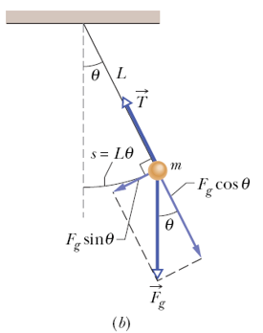
The restoring torque (τ) 回复力矩:
(when its angular displacement is $θ$) (随所在$θ$改变)
$τ = -L\left(mg sinθ\right)=τ=Iα$ (? ← F_{g} = mg ??)
↓
The angular acceleration (α) 角加速度: (随所在$θ$改变)
$α = \frac{τ}{I}=-\frac{mgL}{I}sinθ≈-\frac{mgL}{I}θ=α=-ω^{2}θ$
↓ (↑ $\lim_{θ→0}{\frac{sinθ}{θ}=1}$) → it is a SHM if it swings through only a small angle.
The angular frequency (ω) 角频率 (恒定，不变)
$ω = \sqrt{\frac{α}{-θ}}=\sqrt{\frac{mgL}{I}}=ω=\frac{2π}{T}$
The period (T) 周期 (恒定，不变)
$T = \frac{2π}{ω}=2π\sqrt{\frac{I}{mgL}}$
* Rotational inertia 旋转惯量: $I=mL^{2}$, for Simple Pendulum (We have know)
→ $T=2π\sqrt{\frac{L}{g}}$
($α=-\frac{mgL}{mL^{2}}θ=-\frac{g}{L}θ$)
($ω=\sqrt{\frac{g}{L}}$)
-Small Angle Approximation
Assume that θ<< 1 and use the approximation sinθ≈θ.
→ If we keep θ < 10°, we make less than 1 % error
-Physical Pendulum 物理摆
Complicated distribution of mass.
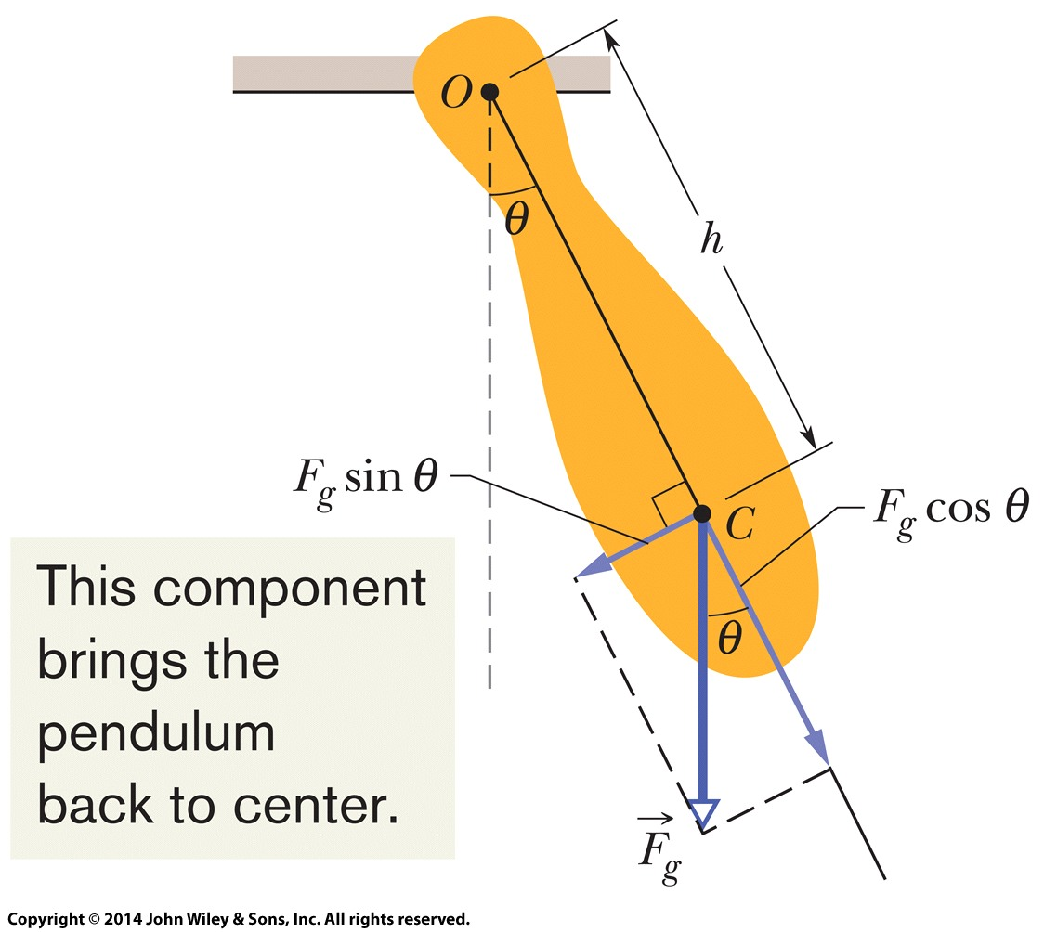
(For) Small Angle Swing:
The period (T) 周期
$T=2π\sqrt{\frac{I}{mgh}}$
h: the distance from the COG(重心) to the pivot point O(旋转轴所在点).
(点O(旋转轴所在点)不一定是悬挂的点! !!, 可能是物体上任意一点)
(Only difference with simple pendulum (where h is the length L of the rope))
I: the rotational inertia of the pendulum about O.
e.g.: uniform rod of length L
$I=I_{com}+Mh^{2}=\frac{1}{12}ML^{2}+Mh^{2}$
$T=2π\sqrt{\frac{I}{Mgh}}=2π\sqrt{\frac{\frac{1}{12}ML^{2}+Mh^{2}}{Mgh}}=2π\sqrt{\frac{\frac{1}{12}L^{2}+h^{2}}{gh}}$
→ Smallest period (T) (一致柱体的周期最小时): when $h=\frac{L}{2\sqrt{3}}$
→ Find $g$ at a particular location by measuring $L$and $T$.
通过测量L和T，得到特定位置上的g
e.g. if $h=\frac{1}{2}L$, $T=2π\sqrt{\frac{\frac{1}{12}L^{2}+{\frac{1}{4}L}^{2}}{g\frac{1}{2}L}}=2π\sqrt{\frac{2L}{3g}}$ → $g=\frac{8π^{2}L}{3T^{2}}$
Find the rotational inertia (I) of different shapes about pivot point
$I_{com}+Mh^{2}=\frac{T^{2}Mgh}{{4π}^{2}}$
e.g.
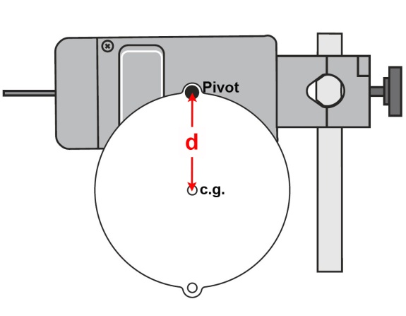
Center of Oscillation 振动中心
Def.: a point on the suspension line of a compound pendulum
where, if the entire mass of the pendulum were concentrated there,
the oscillations would have the same duration (period周期) as previously.
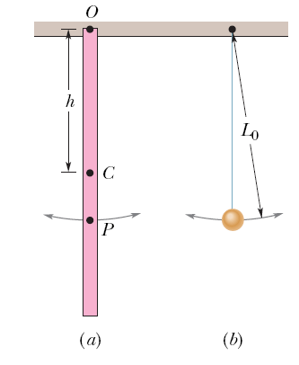
( if you were to imagine that
all of the mass of the stick were concentrated at point P,
then the stick would still oscillate with the same period as it did when it was suspended from point O. )
Point P would be different for a different suspension choice.
-Simple Harmonic Motion & Uniform Circular Motion
简谐运动与匀速圆周运动
Uniform Circular Motion → $P^{'}$ moves at constant angular speed $ω$,
with initial angular position at $∅$
→ Simple harmonic motion:
the projection of uniform circular motion
on a diameter of the circle in which the circular motion occurs.
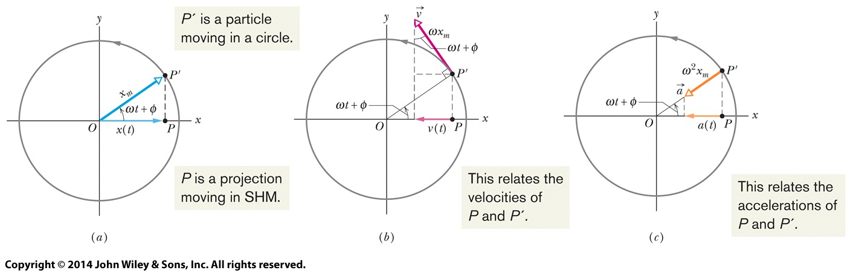
On 𝑥 axis: ($R=x_{m}$)
UCM: $θ\left(t\right)=$ $ωt+∅$
→ SHM: $x\left(t\right)=x_{m}cos[θ(t)]⁡=x_{m}cos⁡(ωt+∅)$
UCM: $v=ωR=ωx_{m}$
→ SHM: $v_{x}=v\left(t\right)=-ωx_{m}sinθ={-ωx}_{m}sin⁡(ωt+∅)$
UCM: $a=a_{r}=\frac{v^{2}}{R}=ω^{2}R=ω^{2}x_{m}$
→ SHM: $a_{x}=a\left(t\right)=-ω^{2}x_{m}cosθ=-ω^{2}x_{m}cos⁡(ωt+∅)$
-Damped Simple Harmonic Motion 阻尼简谐运动
Damped 阻尼的
Def.: the motion of an oscillator is reduced by an external force,
the oscillator and its motion are said to be damped.
Damping Force ${\vec{F}}_{d}$ 阻尼力
Direction: Opposite direction with the velocity 𝑣
Magnitude: $F_{d}=-bv$
𝑏: damping constant 阻尼常数
Depends on the characteristics of
both 1. the vane叶片的特性 & 2. the liquid液体的特性
SI-unit单位: kg/s
e.g.
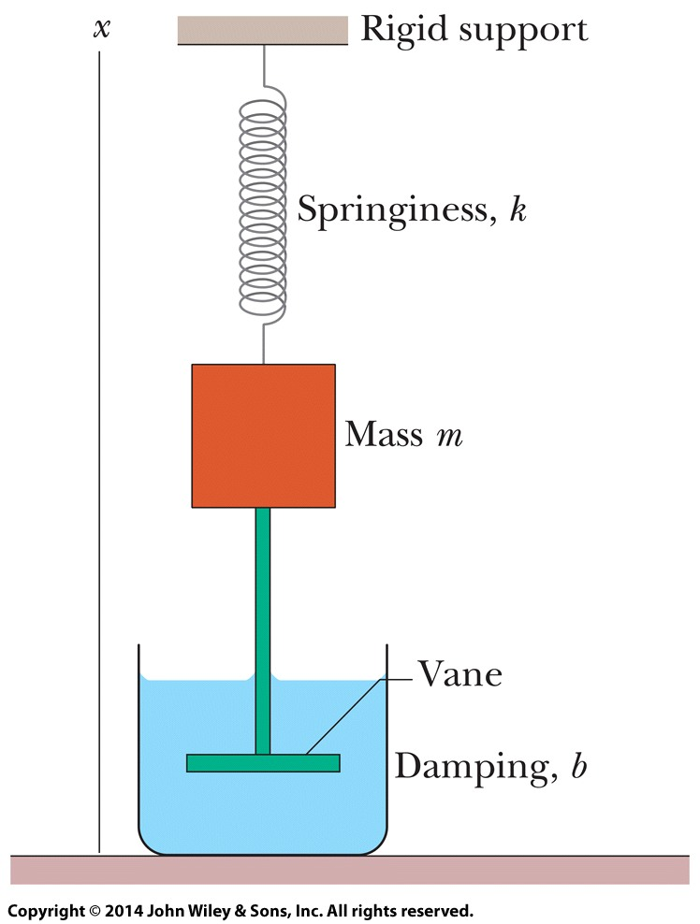
-Damped Oscillation 阻尼振荡
Newton’s Second Law牛顿第二定律:
ignore the gravitational force (???)
$F_{net}=F_{d}+F_{spring}=ma$
→ $-bv-kx=ma$ → $m\frac{dx^{2}}{dt^{2}}+b\frac{dx}{dt}+kx=0$
→→ $x(t)=x_{m}e^{-\frac{bt}{2m}}cos⁡(ω^{'}t+∅)$
e.g.
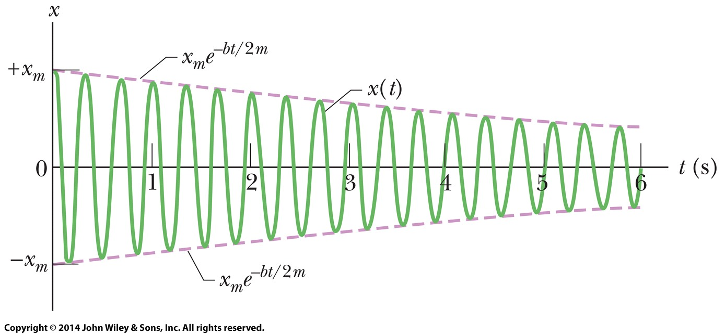
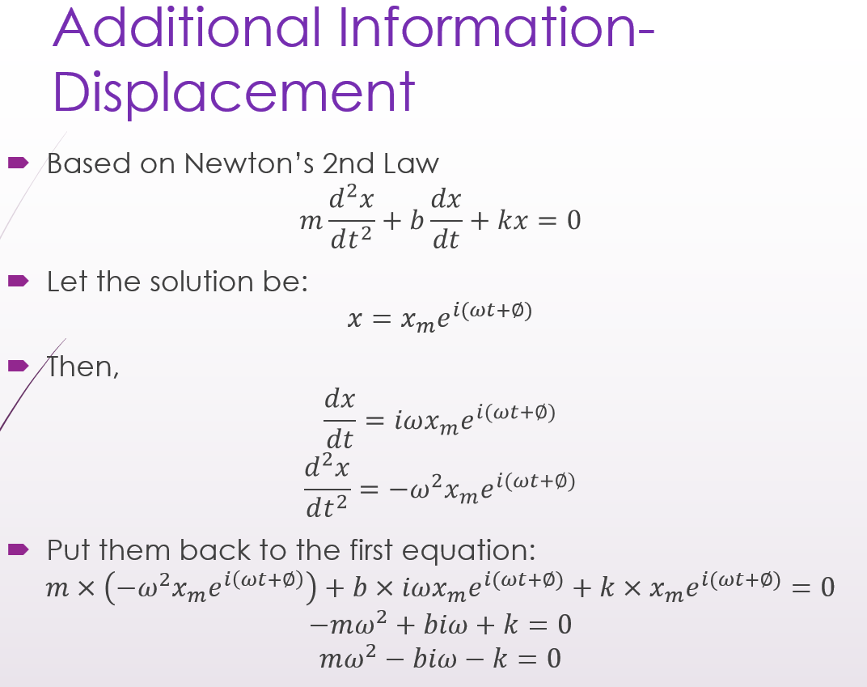
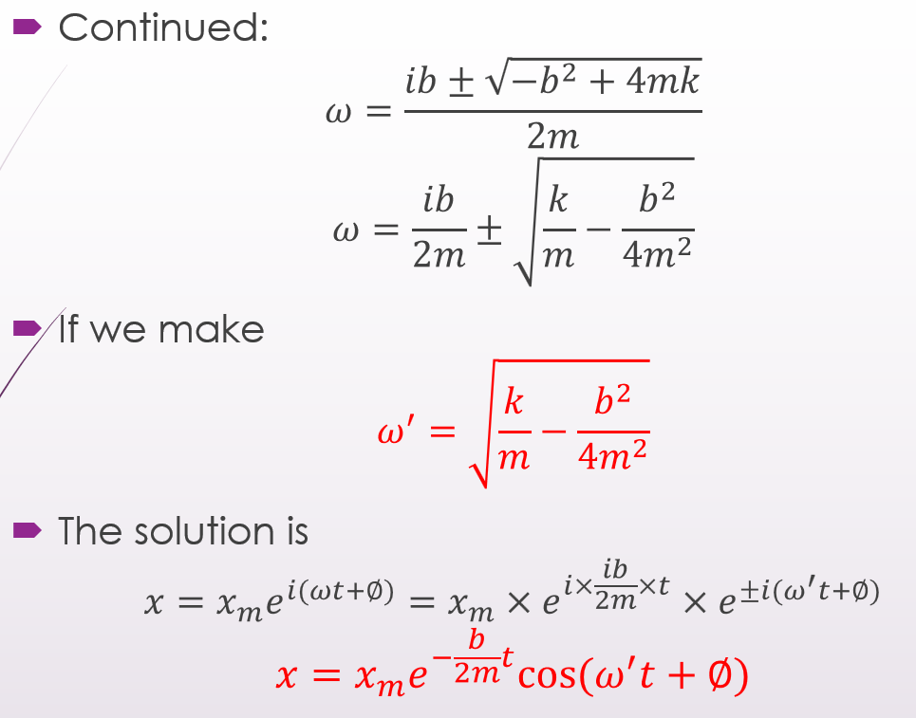
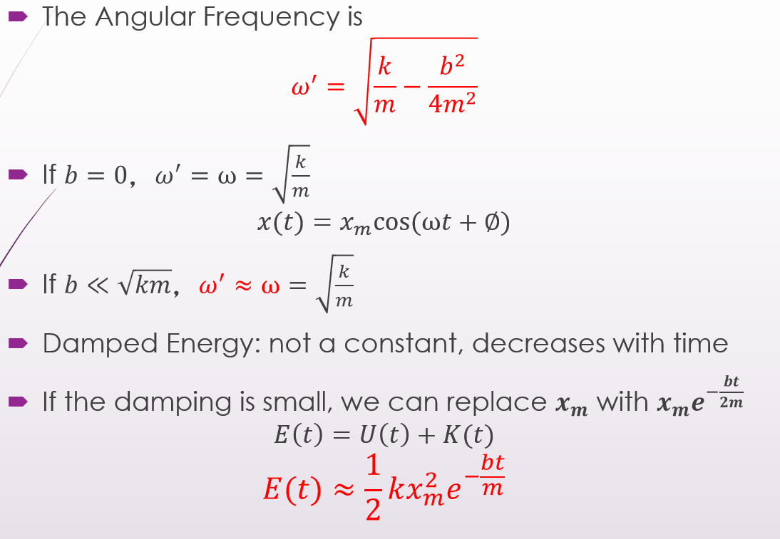
$ω=\sqrt{\frac{k}{m}}$: 阻尼(常数)(b)为0时, (固有?的)角频率
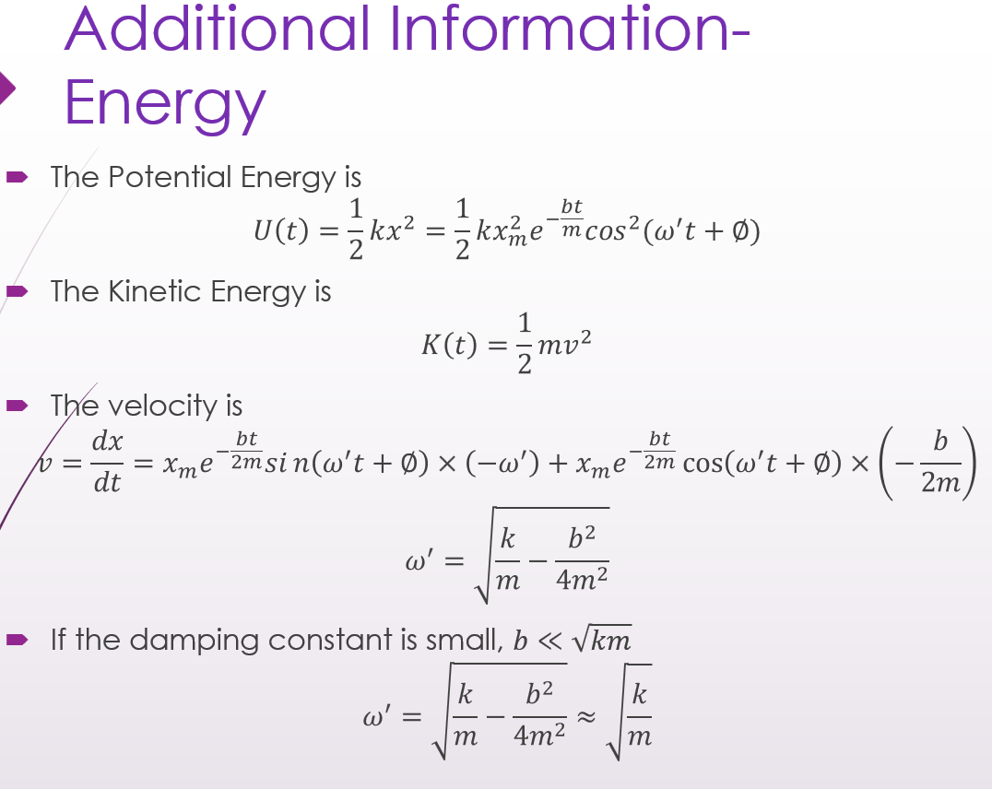
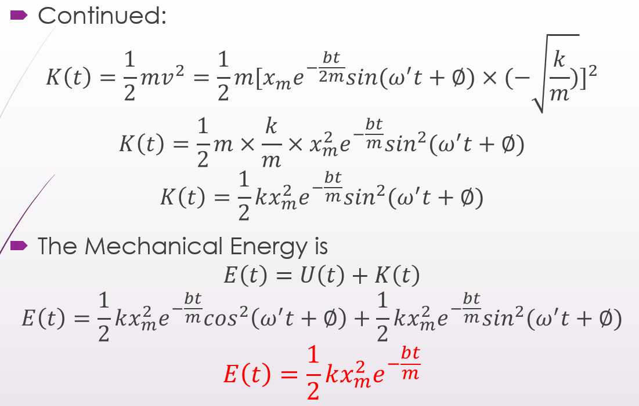
*:
$ω^{'}=\sqrt{\frac{k}{m}-\frac{b^{2}}{{4m}^{2}}}$
$E\left(t\right)≈\frac{1}{2}kx_{m}^{2}e^{-\frac{bt}{m}}$
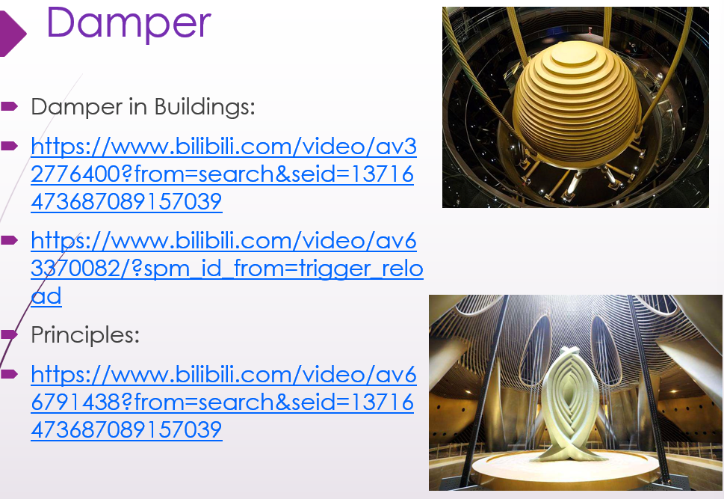
-Forced Oscillation and Resonance
Forced Oscillation (/Driven Oscillation)
Def.: Oscillations that are subject to a(?) periodic applied force.
$x\left(t\right)=x_{m}cos(ω_{d}t+∅)$
$ω_{d}$: Driving frequency驱动频率:
the driving force的angular frequency
Natural frequency固有频率 $ω=\sqrt{\frac{k}{m}}$
Resonance共振: $ω_{d}=ω$时，x_{m}最大、v_{m}最大
-Additional Information-Forced Oscillation for Linear Oscillator
Newton’s 2nd Law and Hooke’s Law
$$F_{net}=ma$$
When the oscillator is driven with a sinusoidal Force
$$F(t)=F_{0}cos⁡(ω_{d}t)$$
Then,
$$F\left(t\right)+\left(-kx\right)=ma$$
$$m\frac{d^{2}x}{dt^{2}}+kx=F_{0}cos⁡(ω_{d}t)$$
The general solution is
$$x_{g}=x_{c}+x_{d}$$
- Where, $x_{c}$ is the (complementary) solution to the equation $m\frac{d^{2}x}{dt^{2}}+kx=0$
- Let’s assume
$$x_{c}=x_{0}cosω_{0}t$$
- Where $ω_{0}$ is the natural angular frequency
$$ω_{0}=\sqrt{\frac{k}{m}}$$
- Let’s assume
$$x_{d}=Acosω_{d}t$$
$$\frac{d^{2}x}{dt^{2}}=-Aω_{d}^{2}cosω_{d}t$$
- Put it back into the differential equation
$$m\frac{d^{2}x}{dt^{2}}+kx=F_{0}cos⁡(ω_{d}t)$$
$$m×-Aω_{d}^{2}cosω_{d}t+k×Acosω_{d}t=F_{0}cos⁡(ω_{d}t)$$
$$\left(k-mω_{d}^{2}\right)A=F_{0}$$
$$A=\frac{F_{0}}{k-mω_{d}^{2}}=\frac{F_{0}}{m(ω_{0}^{2}-ω_{d}^{2})}$$
- Thus,
$$x_{g}=x_{c}+x_{d}=x_{0}cosω_{0}t+\frac{F_{0}}{m(ω_{0}^{2}-ω_{d}^{2})}cosω_{d}t$$

-Additional Information-Driven Damped Angular Harmonic Oscillations
- Example shown in the experiment
$$κ=\frac{τ}{θ}$$
$$\frac{d^{2}θ}{dt^{2}}+\left(\frac{b}{I}\right)\frac{dθ}{dt}+\left(\frac{κ}{I}\right)θ=0$$
- The solution to this equation is a damped sine wave:
$$θ=θ_{o}e^{-\left(\frac{b}{2I}\right)t}sin(ωt+φ)$$
- where the angular frequency is given by
$$ω=\sqrt{\frac{κ}{I}-\frac{b^{2}}{4I^{2}}}$$
- Continued:
- When the damped oscillator is driven with a sinusoidal torque, the differential equation describing its motion is
$$I\frac{d^{2}θ}{dt^{2}}+b\frac{dθ}{dt}+κθ=τ_{o}\cos\left(ωt\right)$$
- The solution to this equation is
$$θ=\frac{{τ_{o}}/I}{\sqrt{{\left(ω^{2}-ω_{o}^{2}\right)}^{2}+{\left(b/I\right)}^{2}ω^{2}}}\cos\left(ωt-φ\right)$$
- where the amplitude of the oscillation is
$$θ_{o}=\frac{{τ_{o}}/I}{\sqrt{{\left(ω^{2}-ω_{o}^{2}\right)}^{2}+{\left(b/I\right)}^{2}ω^{2}}}$$
and
$$φ=\tan^{-1}\left(\frac{ωb/I}{ω_{o}^{2}-ω^{2}}\right)$$
(Forced oscillations at resonant frequency may result in rupture or collapse)

Ch16 Waves-I
-Wave
Def.(?): A wave can be any kind of oscillation that travels in space and transfers energy from one place to another place.
-Types of Waves
Electromagnetic Waves
Follow Maxwell’s Equation
Require no medium to travel
and all travel at the same speed 𝑐=299792458 𝑚/𝑠 in vacuum
e.g.: Visible Light, radio waves, X-ray and etc.
Matter Waves:
Follow Schrodinger’s Equation and Dirac’s Equation
e.g.: Particles in quantum mechanics, like electrons, protons, and other fundamental particles, and even atoms and molecules.
Mechanical Wave:
Governed by Newton’s Law
Exist only within a materials Medium
e.g.: Water Wave, Sound Wave, and Seismic Wave;
Transverse and Longitudinal waves:
-Transverse Waves 横波
Def.: has its oscillations perpendicular to the direction the wave moves.
* The materials are not moves from one end to another.
- Wave Equation
$y=h(x,t)$
y: the transverse displacement of any string element
x: position of the element along the string at time t
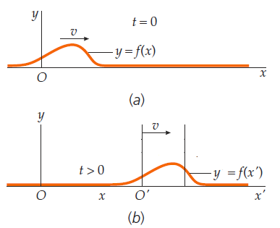 $h\left(x^{'}\right)=h(x-vt)$
→→ $y\left(x,t\right)=h(x±vt)$ → $\frac{∂^{2}y}{∂x^{2}}=\frac{1}{v^{2}}\frac{∂^{2}y}{∂t^{2}}$
· $y\left(x,t\right)=h(kx±ωt)$,
h: represents any function
Periodic Wave
Def.: Spatially repeats its shape along the direction of wave’s travel.
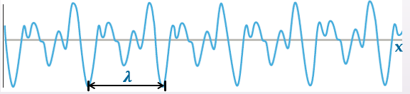
Wavelength (λ) 波长
Def.: The minimum distance (in parallel to wave’s travel)
between spatial repetitions of a periodic wave
-Sinusoidal Function
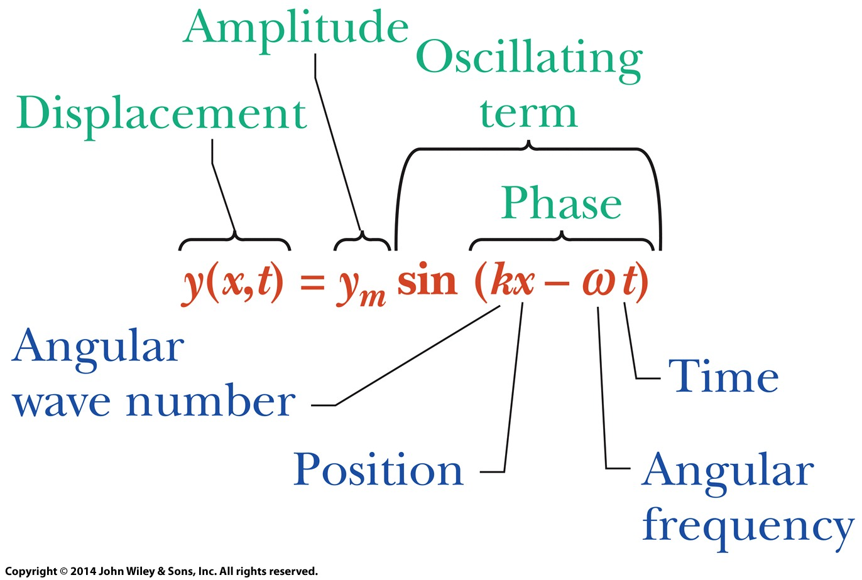
$y\left(x,t\right)=y_{m}\sin\left(kx-ωt\right)$
y_{m}: Amplitude:
Magnitude of the maximum displacement of the element
refer to its equilibrium point平衡点
kx-ωt: Phase: At particular position 𝑥
(the phase changes linearly with time 𝑡)
λ: Wavelength
𝑘: Angular Wave Number
𝑘=2𝜋/𝜆 [←$y\left(x,0\right)=y_{m}sinkx$, $y_{m}sinkx_{1}=y_{m}sink(x_{1}+λ)$]
Unit: rad/m
T: Period:
the time any string element takes to move
through one full oscillation
𝜔: Angular frequency
$ω=\frac{2π}{T}=2πf$
f: Frequency:
a number of oscillations per unit time.
Phase Constant ($∅$) 相位常数
With Phase Constant: $y\left(x,t\right)=y_{m}sin⁡(kx-ωt+∅)$
+$∅$←→-x ; -$∅$←→+x
The effect of the phase constant $∅$ to shift the wave:
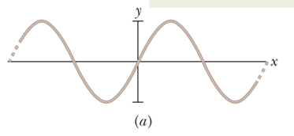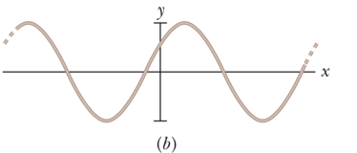
The Speed of a Traveling Wave (v)
$v=\frac{dx}{dt} =\frac{ω}{k} =\frac{\frac{2π}{T}}{\frac{2π}{λ}} =\frac{λ}{T} =λf$
(? $kx+ωt=constant$ → $v=\frac{dx}{dt}=-\frac{ω}{k}$)
The Particle Speed (/The Oscillating Speed?) (u)
$u\left(x,t\right)=\frac{∂y}{∂t}$; $u_{m}={ωy}_{m}$
*different from the wave speed
Wave Speed on a Stretched String
The speed of wave:
set by the properties of the medium介质的性质
--(?) mass(动能) & elasticity(势能)
The linear mass density (𝜇)
for a string: $μ=\frac{m}{l}$
Force ($\vec{τ}$) (magnitude)
= the tension in the string
pulls tangentially
on this element at each end.
Along x-axis:
the components cancel each other
Along y-axis:
$\left\{\begin{aligned}F=2τsinθ≈τ×2θ=τ\frac{∆l}{R} \\ F=∆m×a =μ ∆l×\frac{v^{2}}{R}\end{aligned}\right.$ ($∆m=μ∆l, a=\frac{v^{2}}{R}$)
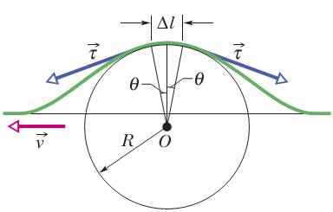
$v=\sqrt{\frac{τ}{μ}}$ ←← $τ\frac{∆l}{R}=μ ∆l×\frac{v^{2}}{R}$ (v: the speed of wave)

1

Ch17 Waves-II
-Transverse and Longitudinal Waves 横波 和 纵波
Transverse wave 横波
Def.: has its oscillations perpendicular to the direction the wave moves.
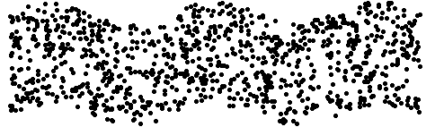
Longitudinal wave 纵波
Def.: has oscillations parallel to the direction the wave moves.
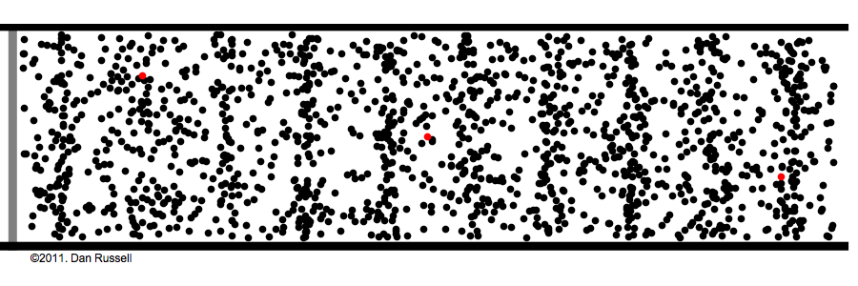
-Sound Wave 声波
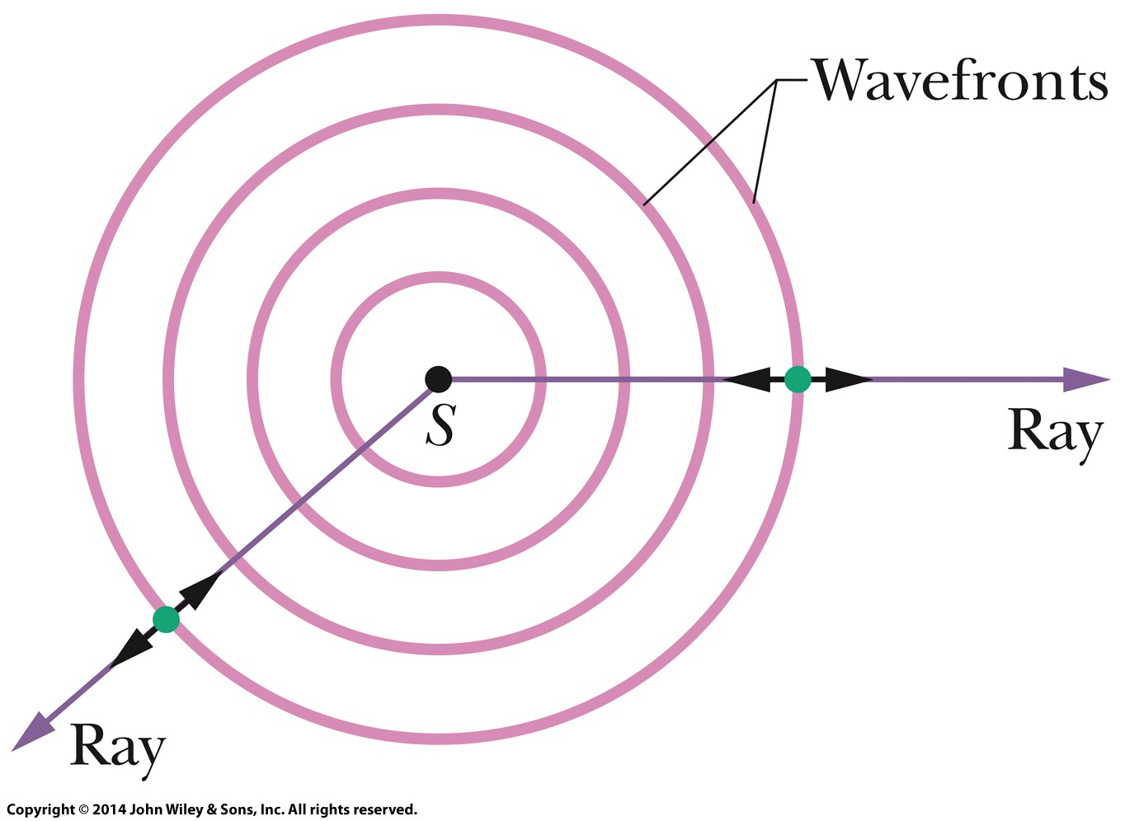S: Point source
Wavefront(s) 波阵面
Def.: surfaces over
which the oscillations
due to the sound wave
have the same value.
(波阵面是一个想象的表面，
代表波的相应点在同一时间振动一致。它是介质中所有相位相同的位置的集合。)
Ray(s)
Def.: directed lines perpendicular to the wavefronts
垂直于波阵面的定向线
that indicate the direction of travel of the wavefronts
指示波阵面的行进方向
(图中的Double Headed Arrows:
indicates the elements of the medium oscillate parallel to the rays.
表示与rays平行地(?)振荡的介质元素。)
Speed of Sound 声速
For mechanical wave: depends on the medium
$v=\sqrt{\frac{τ}{μ}}=\sqrt{\frac{elastic property}{inertia property}}$
For sound wave through air:
$v=\sqrt{\frac{B}{ρ}}$ (the speed of sound)
(↑ Derivation(n.)推导: $\left\{\begin{aligned}∆p=B\frac{∆V}{V}=B\frac{∆v∆tA}{v∆tA}=B\frac{∆v}{v} ① \\ ∆p=ρv∆v ②\end{aligned}\right.$)
(② ← $\left\{\begin{aligned}∆m\frac{∆v}{∆t}=F=\left(p+∆p\right)A-pA=∆pA \\ ∆m=ρA∆x=ρAv∆t\end{aligned}\right.$)
𝐵: the bulk modulus (Pa)
𝜌: the density
↓ Bulk Modulus (Ch 12): $B_{solid}≫B_{liquid}≫B_{gas}$
↓ (Solid is more incompressible (less compressible) than liquid, …)
Sound Speed: $v_{solid}≫v_{liquid}≫v_{gas}$

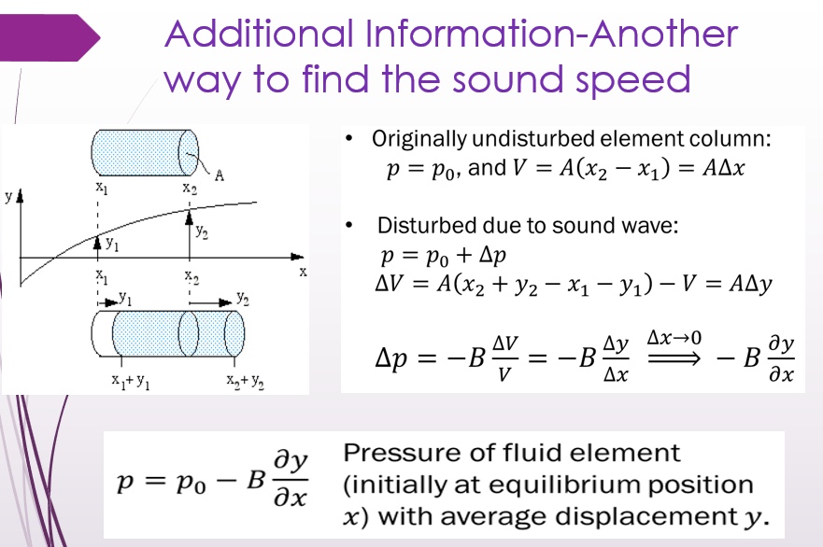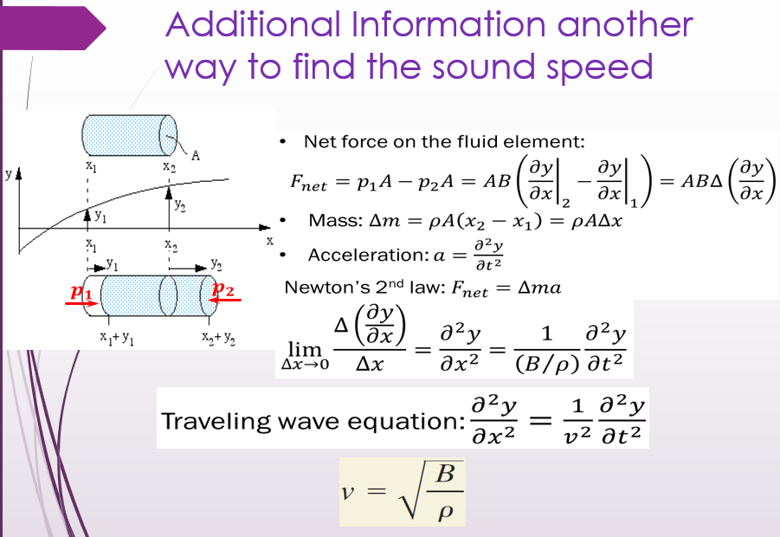
(* $v=\sqrt{\frac{E}{ρ}}$ ??? ! (E: Young’s modulus, $\frac{F}{A}=E\frac{∆L}{L}$))
-Traveling Sound Wave 行进中的声波
A longitudinal wave纵波, the particle displacement is in the x-direction.
Replace y(x, t) by s(x, t) （s(x, t) points in the x-direction）

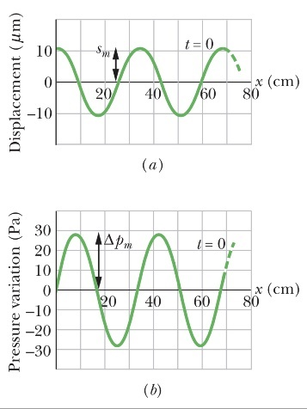
Sinusoidal Function of Displacements
$s\left(x, t\right)=s_{m}\cos\left(kx-ωt\right)$
s(x, t)=0 (0 displacement):
可能是在Compression(处)或者Expansion(处)
velocity速度: $u\left(x,t\right)=\frac{∂s}{∂t}=ωs_{m}sin⁡(kx-ωt)$
acceleration加速度: $a\left(x,t\right)=\frac{∂u}{∂t}=-ω^{2}s_{m}cos⁡(kx-ωt)$
· $s_{m}$: Displacement amplitude
The maximum displacement of the air element
to either side of its equilibrium place.
(displacement:
the movement of an air particle from its original position)
(the equilibrium position:
the position where the air particle would be
if there were no sound wave present.)
The displacement of element at origin (x=0)
(is not the equilibrium displacement)
(?) the midway中途 between Expansion扩展 and Compression压缩
(find 𝑘, 𝜔, 𝜆, 𝑓, 𝑇 and 𝑣 as Transverse waves)
The Pressure Variation
$∆p\left(x,t\right)=∆p_{m}sin⁡(kx-ωt)$
· ${∆p}_{m}$: Pressure amplitude $∆p_{m}(=Bks_{m}=v^{2}ρks_{m})=vρωs_{m}$
Def.: The maximum increase or decrease in pressure
due to the wave.
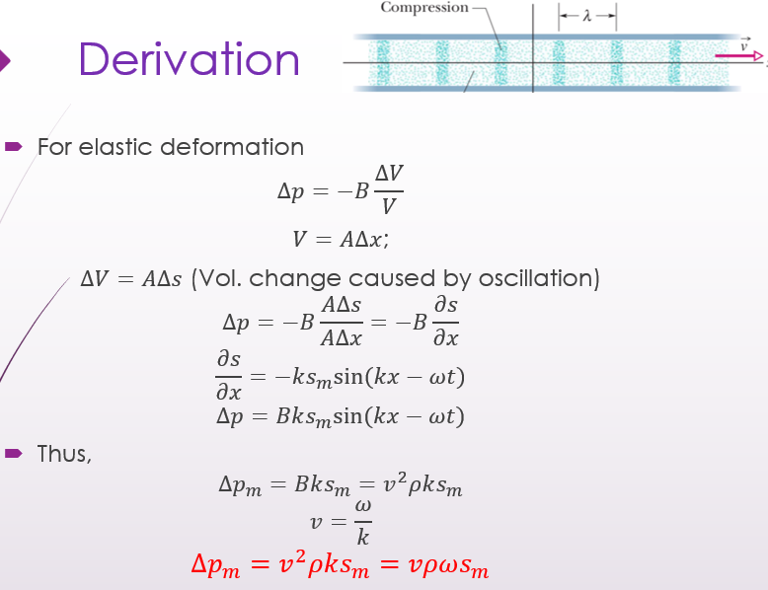

-Interference 干涉
2个具有相同amplitude和wavelength的声波
If: traveling in (+x) the positive direction of an x-axis
with a phase difference $∅$:
Wave 1: $s_{1}\left(x, t\right)=s_{m}\cos\left(kx-ωt\right)$
Wave 2: $s_{2}\left(x, t\right)=s_{m}\cos\left(kx-ωt+∅\right)$
↓
Resultant Wave:
$s^{'}\left(x, t\right)={2s}_{m}cos⁡(\frac{∅}{2})\cos\left(kx-ωt+\frac{∅}{2}\right)$
$s_{m}^{'}$: amplitude of the resultant wave
$s_{m}^{'}=|{2s}_{m}cos⁡(\frac{∅}{2})|$
$∅$: the phase difference
$∅=2π\frac{∆L}{λ}$ (← $\frac{∅}{2π}=\frac{∆L}{λ}$)
$∆L$: the path length difference: $∆L=|L_{2}-L_{1}|$
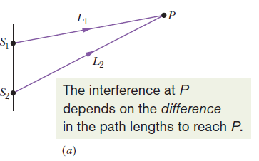
Fully Constructive ← $∆L=nλ (n=0,1,2…)$
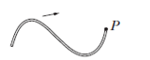
Fully Destructive ← $∆L=\left(n+\frac{1}{2}\right)λ (n=0,1,2…)$
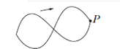

-Intensity of Sound (I) 声音强度
the intensity (I) of a sound wave at a surface
Def.: the average rate
per unit area
at which energy is transferred
by the wave through or onto the surface.
波 通过或传递 到表面 的能量 的每单位面积 的(通过或传递的)平均速率。
$I=\frac{P}{A}$ (P: The power (功率 time rate of energy transfer))
$=\frac{1}{2}ρvω^{2}s_{m}^{2}$ (if the displacement amplitude of the sound wave is s_{m})
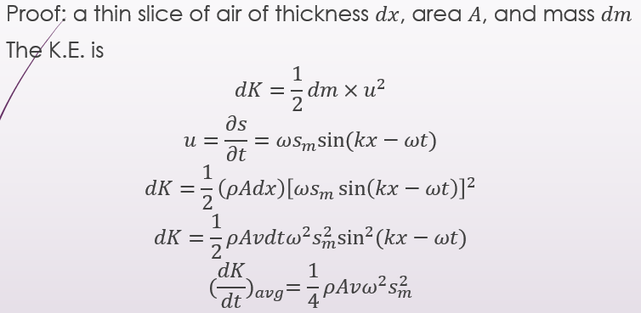
e.g.: For an isotropic各向同性的 point source点源 with power $P_{s}$:
$I=\frac{P_{s}}{4πr^{2}}$ (→ r↑, I↓)
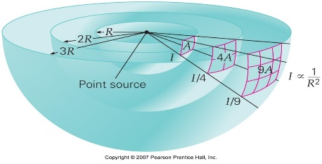
-Standing Wave in Pipes 管道中的 驻波
Pipe: Two open Ends
$L=\frac{n}{2}λ$, for $n=1, 2, 3…$
$λ=\frac{2L}{n}$
The resonant frequency $f=\frac{v}{λ}=\frac{nv}{2L}$ ($n=1, 2, 3…$)
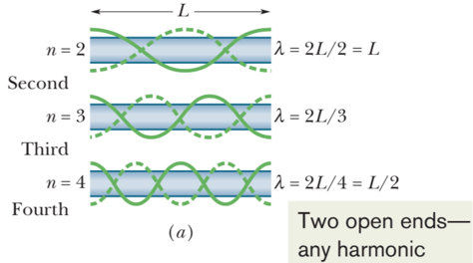
Pipe: One open End
(One is antinode and one is Node;
similar to one hard boundary, and one free boundary)
$L=\frac{n}{4}λ$, ($n=1, 3, 5…$)
$λ=\frac{4L}{n}$
The resonant frequency $f=\frac{v}{λ}=\frac{nv}{4L}$ ($n=1, 3, 5…$)
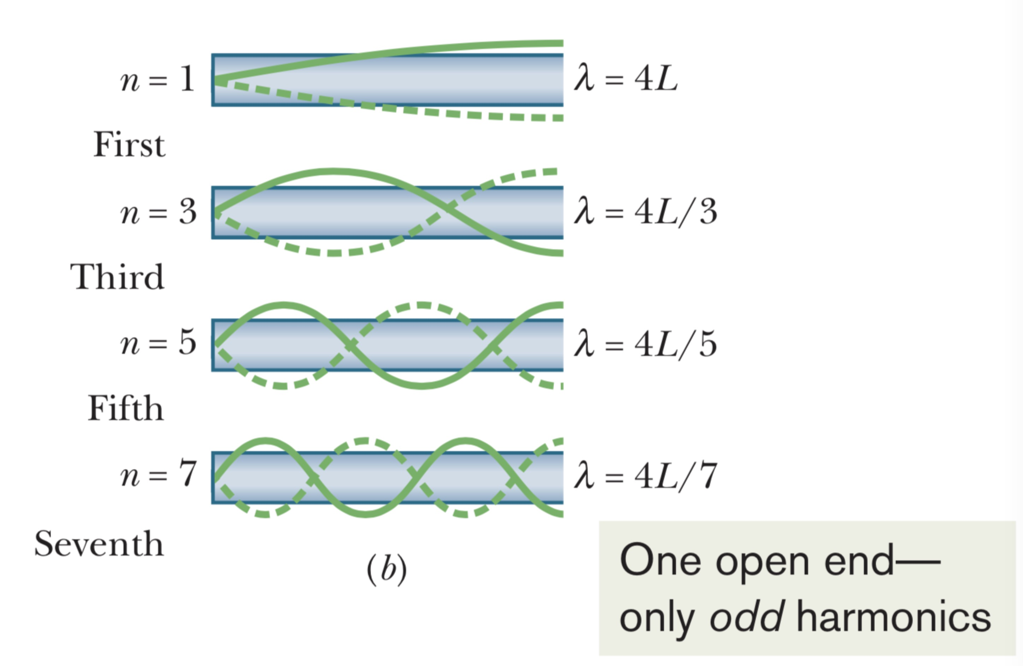
-Beats 节拍
Beat phenomena:
two almost identical waves
with the same amplitude
but two frequencies slightly different
their interference →
a resultant wave with intensity fluctuating
at a frequency equal to
the frequency difference between the two waves
$f_{beat}=|f_{1}-f_{2}|$
$s_{1}=s_{m}\cos{(kx+ω_{1}t)}$, $s_{2}=s_{m}\cos{(kx+ω_{2}t})$
→ $s^{'}=s_{1}+s_{2}=2s_{m}\cos{ω^{'}t}cos(kx+{ωt})$,
where $ω^{'}=\frac{1}{2}(ω_{1}-ω_{2})$ and $ω=\frac{1}{2}(ω_{1}+ω_{2})$ ($ω≫ω'$)
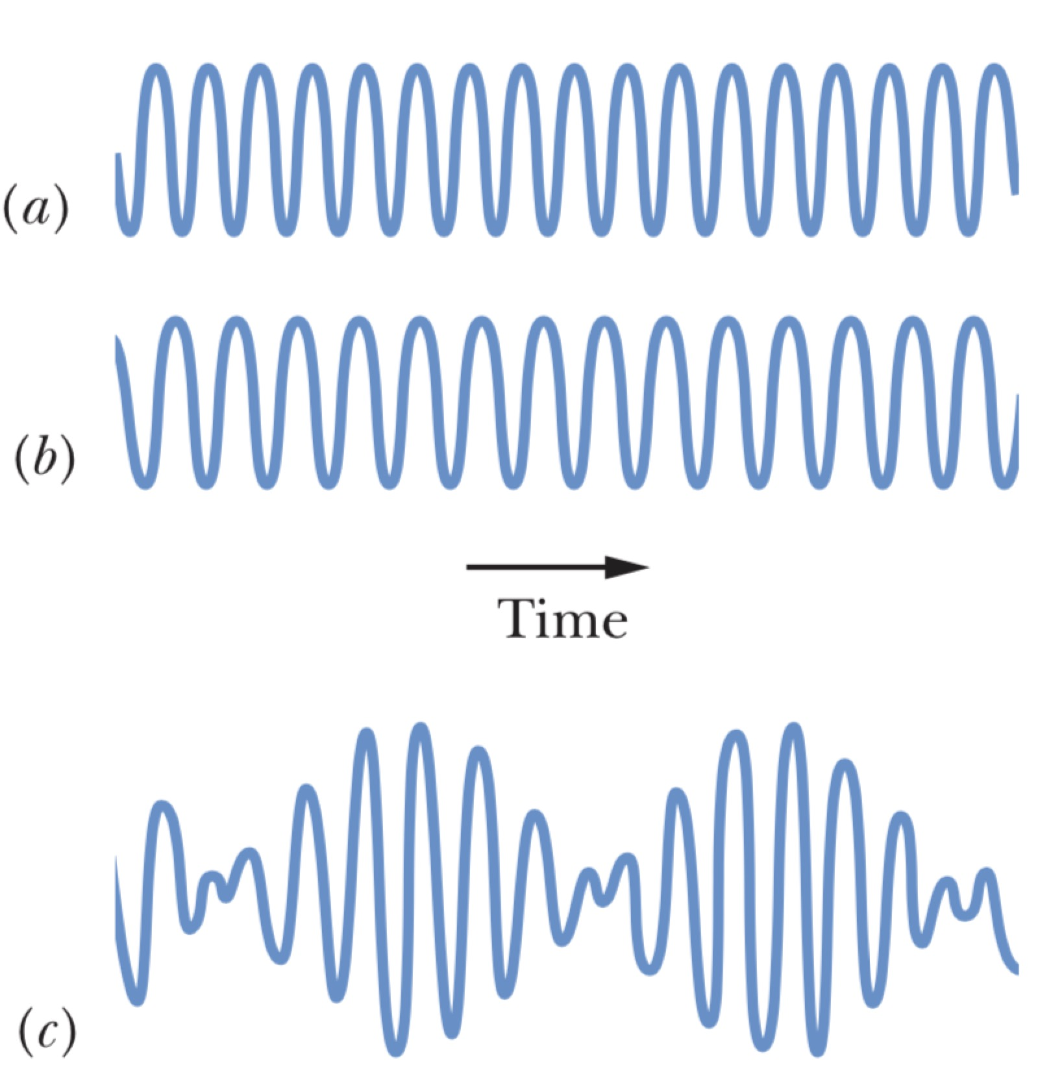
→ $s_{m}^{'}=|2s_{m}\cos{ω^{'}t}|$
$ω_{beat}=2ω^{'}=|ω_{1}-ω_{2}|$ (?)
$f_{beat}=|f_{1}-f_{2}|$
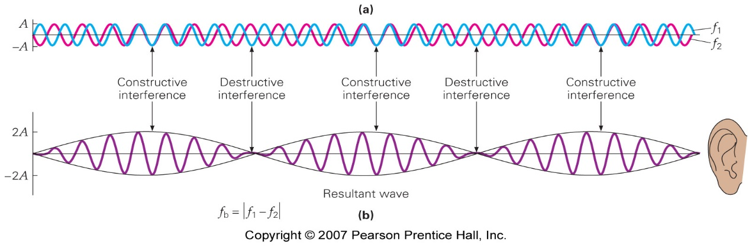
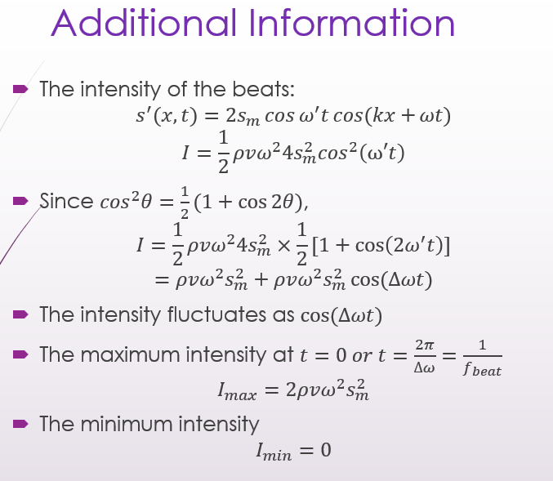
-The Doppler Effect
When the source and the detector of a wave have relative motion,
the frequency 𝑓’ probed (“felt”) by the detector
(i.e., the rate for receiving wavefronts)
is different from the frequency 𝑓 at which the source emits wavefronts.
-Supersonic Speeds
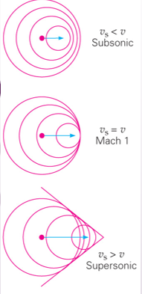
Moving Source and Stationary detector:
$f^{'}=f\frac{v}{v-v_{s}}$
(If $v=v_{s}$, the source keep pace with its own spherical wavefronts)
If $v<v_{s}$: the general equation doesn't work
outpace its sound waves, creating a sonic boom.
A similar phenomenon: the wake from a boat
-Shock Waves
The Mach cone angle马赫锥角: $\sin{θ}=\frac{vt}{v_{s}t}=\frac{v}{v_{s}}=\frac{1}{M}$
M: The Mach number (?)
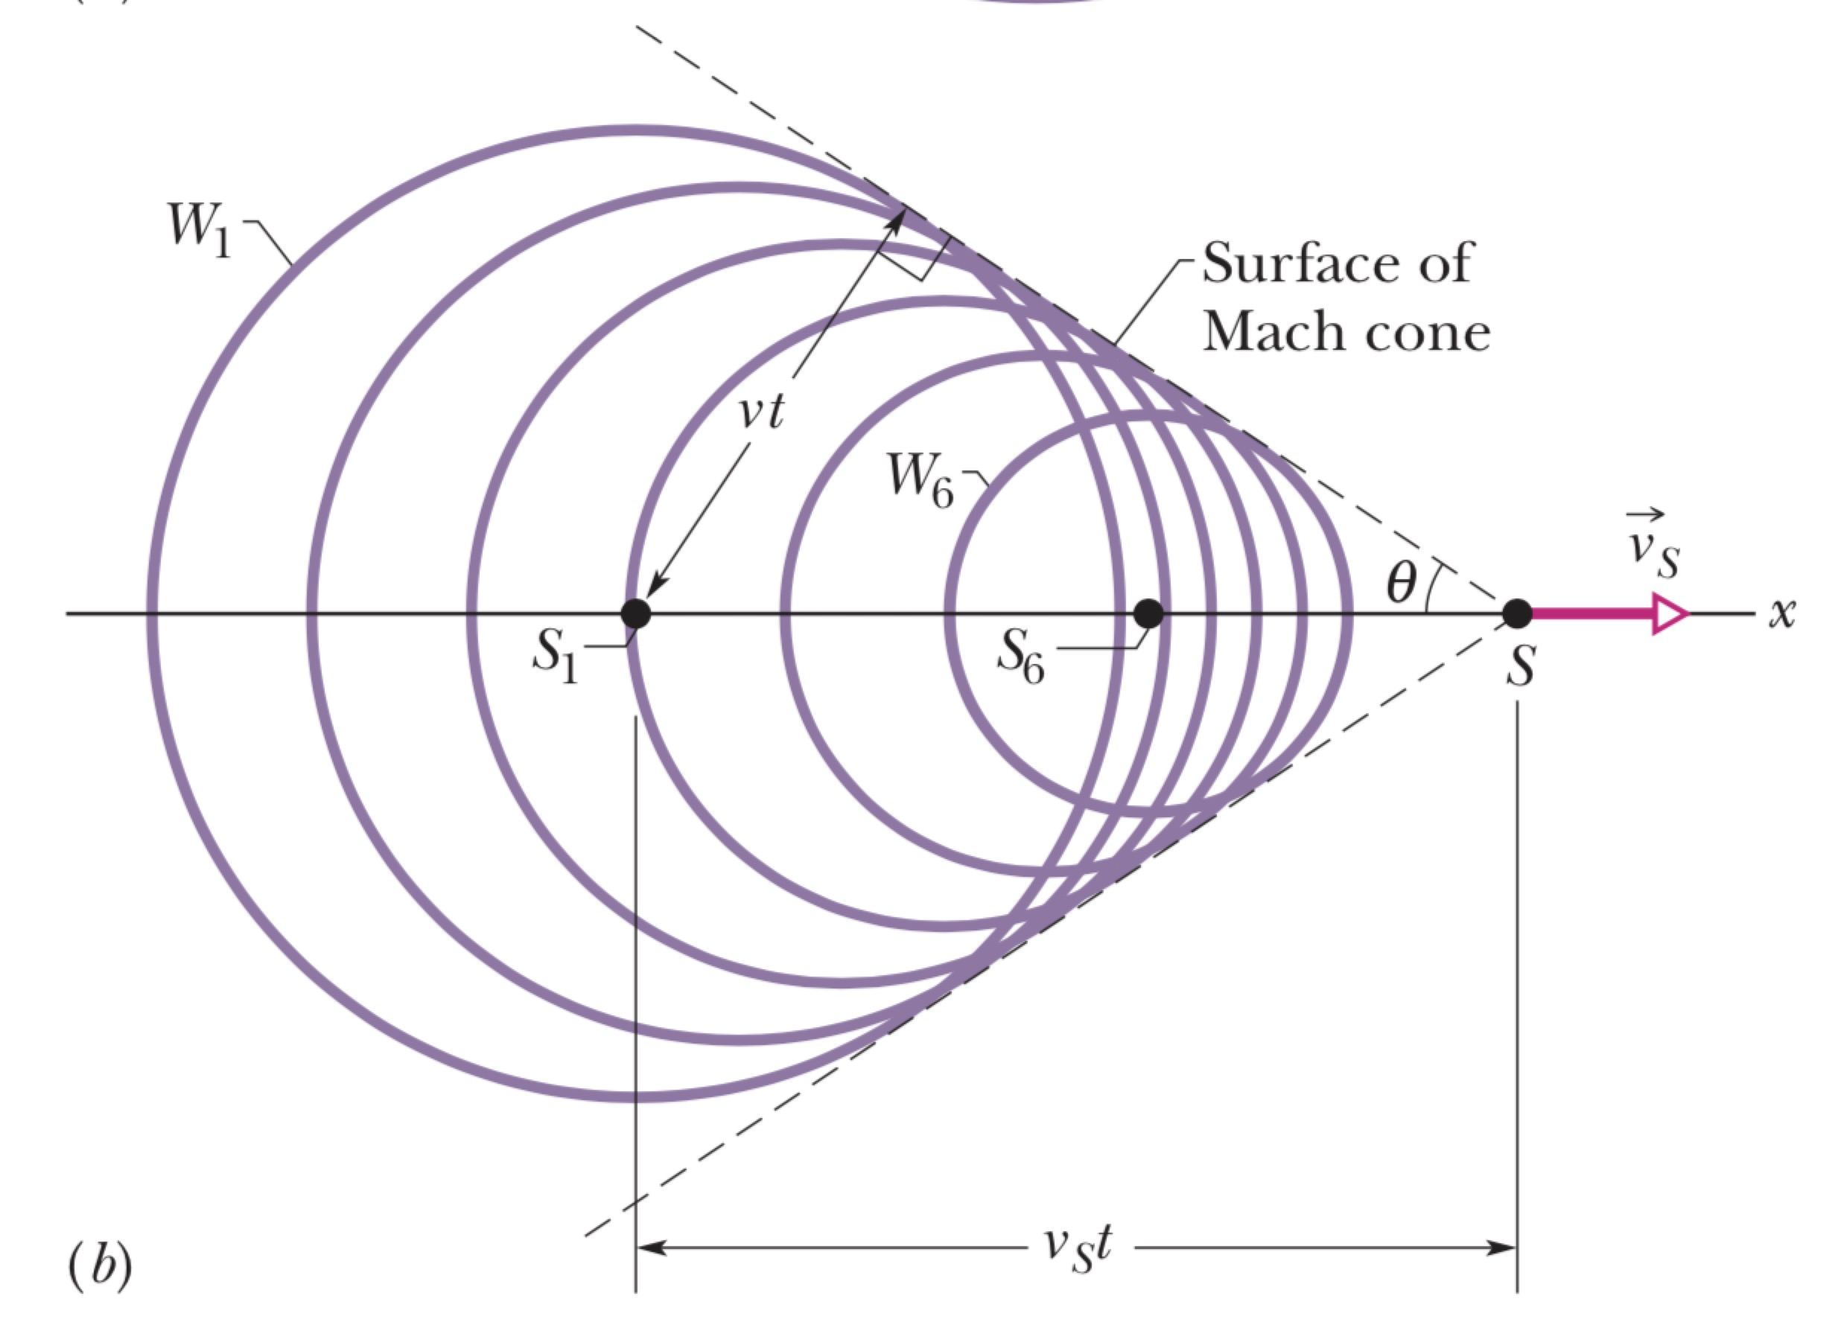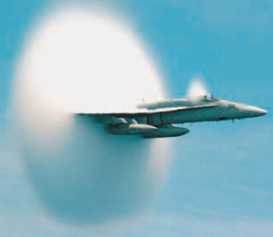

( (???) effective moment arm of the torque r_{eƒƒ} = τ/ F ).

